

**PROJECT REPORT ON**

**“ONLINE QUIZ SYSTEM”**

FOR

**BCA DEPARTMENT**

OF

**MAGADH MAHILA COLLEGE**

**Carried and Submitted by:**

|  |  |
| --- | --- |
| Ayushi Kumari | (40117) |
| Kaajal Kaushal | (40123) |
| Mahi | (40125) |
| Mohni Kumari | (40127) |

Under the Guidance of

**Ms Sabitri Sharma**

**ACKNOWLEDGEMENT**

We wish to express our sincere gratitude and thanks to many persons who helped us to develop this project. We extend our gratitude to our respected Principal **Prof. Dr. Shashi Sharma**, Magadh Mahila College for providing the facilities without which it would have been impossible to complete this project.

Our due thanks to our Course Coordinator **Dr.** **Binay Kumar,** under whose guidance and help we were able to complete this project.

Our foremost thanks to **Ms** **Sabitri Sharma**, for helping and guiding us to complete this project. We take this opportunity to express our gratitude and thanks for her inspiration and guidance throughout this project.

**CERTIFICATE OF APPROVAL**

I am satisfied that the project titled Online Quiz System for Department of Computer Application of Magadh Mahila College, Patna University, Patna by **Ayushi Kumari** Roll 40117, **Kaajal Kaushal** Roll 40123, **Mahi** Roll 40125 and **Mohni Kumari** Roll 40127 of Computer Application course session 2018-2021 is worthy of consideration in partial fulfillment of the requirement of the award of degree of B.Sc. in Computer Applications of Patna University.

The project report is a record of original bonafide work carried out by them. The results contained in the report have not been submitted in part or full to any other university or institute for award of any degree / diploma.

……………………………… …………………………… ……………………………..

**Course Coordinator Examiner (I) Examiner (II)**

To Whom It May Concern

*Subject: Completion of Project*

This is to certify that**Ayushi Kumari**Roll No. –40117 Registration No. 09180010, **Kaajal Kaushal** Roll No. – 40123 Registration No. 09180016, **Mahi** Roll No. – 40125 Registration No. 09180018 and **Mohni Kumari** Roll No. – 40127 Registration No. 09180020 are students of B.Sc in Computer Applications course in Magadh Mahila College of Patna University. They have undergone three months project training in Department of Computer Applications of Magadh Mahila College, Patna University, Patna.

The project was titled **“Online Quiz System for Department of Computer Applications of Magadh Mahila College”**, guided by Ms Sabitri Sharma, Visiting Faculty, Department of Computer Applications.

They have shown great enthusiasm and commitment during the project tenure. The job assigned to them was completed successfully.

We wish them all success in life.

(Ms Sabitri Sharma) (Dr. Binay Kumar)

**Guide Course Coordinator**

**B.A./B.Sc. in Computer Applications B.A./B.Sc. in Computer Applications**

**Magadh Mahila College Magadh Mahila College**

**CONTENTS**

**Topics**

* About Project
* About The Institute
* Objectives
* Tools and platforms
  + - Front End
    - Back End
* Feasibility Analysis
  + Economic Feasibility
  + Technical Feasibility
  + Operational Feasibility
* System Design
* Database Design
  + Tables
* Entity Relationship Diagram
* Data Flow Diagram
* Runtime Windows
* Codes
* Limitation
* Future Scope
* Conclusion
* References

**INTRODUCTION**

***Online Quiz System*** is designed with the purpose of allowing the students to take quiz / test and download their certificates. It is a Multiple Choice Questions (MCQ) based system. This site is an attempt to remove the existing flaws in the manual system of conducting exams.Students are provided the flexibility to choose among different types of programming language quizzes according to their interest.

The main purpose of the system is to efficiently evaluate the students thoroughly through a fully automated system that not only saves a lot of time but also gives fast results. The key concept is to minimize the amount of paper and convert all forms of documentation to digital form.

There are two interfaces of login: Teacher login and Student login. Teacher has authority to make questions give multiple choice options and provide answers. Students are responsible for taking quizzes. They can register them for particular quiz. They can use this quiz system for learning different sections while playing different quizzes.

**ABOUT THE INSTITUTE**

Magadh Mahila College, the oldest premier institute for women in Bihar was established in 1946. It is a **multi faculty** college, began as a Government College and today holds the pride of place as a constituent unit of **Patna University**, teaching a vastly diverse number of the holiest river in India, it stands tall in its achievements in providing quality education in an exclusive campus for women, providing myriad facilities. The college is permanently affiliated under section **12 B of U.G.C act since 1952**. It has been reaccredited with **“B+” grade** by the **NAAC**.

The students of Magadh Mahila College have excelled in academics, as well as in sports and music for the last six decades. They have also brought accolades to the college with their extra ordinary performances in software engineering and IT sectors. The alumnae of the college are holding responsible positions in many public and private sectors organizations as Doctors, Engineers, Lawyers, Academicians, Bankers, and Software Developers etc. Some of them are successful entrepreneurs too. Our alumni also represented as members of Lok Sabha, Legislative Assembly, and Legislative Council. **Dr. Kiran Ghai** an alumni of this college has been elected as a member of Bihar Legislative Council for the second term (2010-2015). **Dr. Sukhada Pandey**, Former Principal was elected an MLA in 2010 election and joined as the Minister for Youth and Culture Affairs, Government of Bihar.

**Objectives**

The teachers and staff take a keen interest in student’s activities and work towards making the students realize the following objectives:

* To be good citizens of the country.
* To pursue knowledge and apply it gainfully.
* To be committed to honesty, integrity and loyalty.
* To develop scientific awareness and scientific outlook.
* To rise above cast, creed and religious fundamentalism.
* To be sensitive to the needs of the weaker sections of the society.
* To develop sportsmanship and have respect for healthy competition.
* To be sensitive towards environmental degradation and preserve the ecology.
* To be strong physically and emotionally and to be able to face the realities of life.

**OBJECTIVES**

* To design and develop Online Quiz System.
* Students / participants can login through any device with their login id and password and can take their test.
* Faculties can make questions give multiple choice options and provide answers.
* Physical appearance is not necessary.
* No need of going to any physical destination.

**TOOLS AND PLATFORMS**

* Operating System : Windows 10
* Front End : HTML, CSS, JavaScript
* Back End :Java
* Database : MySQL

**FRONTEND**

**HYPER TEXT MARKUP LANGUAGE (HTML)**

Hypertext Markup Language (HTML) is the standard markup language for documents designed to be displayed in a web browser. It can be assisted by technologies such as Cascading Style Sheets (CSS) and scripting languages such as JavaScript.

Web browsers receive HTML documents from a web server or from local storage and render the documents into multimedia web pages. HTML describes the structure of a web page semantically and originally included cues for the appearance of the document.

HTML elements are the building blocks of HTML pages. With HTML constructs, images and other objects such as interactive forms may be embedded into the rendered page. HTML provides a means to create structured documents by denoting structural semantics for text such as headings, paragraphs, lists, links, quotes and other items.

HTML elements are delineated by tags, written using angle brackets. Tags such as <img /> and <input /> directly introduce content into the page. Other tags such as <p> surround and provide information about document text and may include other tags as sub-elements. Browsers do not display the HTML tags, but use them to interpret the content of the page.

HTML can embed programs written in a scripting language such as JavaScript, which affects the behavior and content of web pages. Inclusion of CSS defines the look and layout of content. The World Wide Web Consortium (W3C), former maintainer of the HTML and current maintainer of the CSS standards, has encouraged the use of CSS over explicit presentational HTML since 1997.

**CSS**

Cascading Style Sheets (CSS) is a style sheet language used for describing the presentation of a document written in a markup language such as HTML. CSS is a cornerstone technology of the World Wide Web, alongside HTML and JavaScript.

CSS is designed to enable the separation of presentation and content, including layout, colors and fonts. This separation can improve content accessibility, provide more flexibility and control in the specification of presentation characteristics, and enable multiple web pages to share formatting by specifying the relevant CSS in a separate .css file which reduces complexity and repetition in the structural content as well as enabling the .css file to be cached to improve the page load speed between pages that share the file and its formatting.

**JAVASCRIPT**

JavaScript, often abbreviated as JS, is a programming language that conforms to the ECMAScript specification. JavaScript is high-level, often just-in-time compiler and multi-paradigm. It has curly-bracket syntax, dynamic typing, prototype-based object-orientation and first-class functions.

Alongside HTML and CSS, JavaScript is one of the core technologies of the World Wide Web. JavaScript enables interactive web pages and is an essential part of web applications. The vast majority of websites use it for client-side page behavior and all major web browsers have a dedicated JavaScript engine to execute it.

The use of JavaScript has expanded beyond its web browser roots. JavaScript engines are now embedded in a variety of other software systems, both for server-side website deployments and non-browser applications.

**BACK END**

**JAVA**

Java is a class-based, object-oriented programming language that is designed to have as few implementation dependencies as possible. It is a general-purpose programming language intended to let application developers write once, run anywhere (WORA), meaning that compiled Java code can run o all platforms that supports java without the need for recompilation. Java applications are typically complied withbyte code that can run on any Java Virtual Machine (JVM) regardless of the underlying computer architecture. The syntax of Java is similar to C and C++, but has fewer low-level facilities than either of them. The Java runtime provides dynamic capabilities that are typically not available in traditional compiled languages.

Java is one of the most popular programming languages in the world which is easy to learn and simple to use. It is open-source, free, secure, fast and powerful. It has a huge community support.

**FEASIBILTY ANALYSIS**

Feasibility study is a high level version of the entire system analysis and design process.

The purpose of feasibility study is not to solve the problem but to determine if the problem is worth solving.

It is conducted to select the best system that meets performance requirements.

A system’s required the identification of specific system objectives, and a description of outputs defines performance.

Three key considerations are involved in the feasibility analysis.

* Economic Feasibility
* Technical Feasibility
* Operational Feasibility

**ECONOMIC FEASIBILITY**

Economic analysis is the most frequently used method for evaluating the effectiveness of the proposed system. This is an ongoing effort that improves in accuracy at each phase of the system life cycle.

As the necessary software and hardware is available in the organization, the initial investment for the proposed system is NIL. The proposed system minimizes the time and effort right for quiz.

The faculty sitting at his desk can make questions and add answers without directly meeting the student. .

Thus, the proposed system is economically feasible.

**TECHNICAL FEASIBILITY**

It centers around the existing computer system (hardware, software, etc.) and to what extent it can support the proposed system. The necessary hardware and software tools are available in the organization and the software recommendedsupports the system objectives. Thus it is technically feasible to design and develop the proposed system.

**OPERATIONAL FEASIBILITY**

People are inherently resistant to change, and computers have been known to facilitate change. An estimate should be made of how strong a reaction the user is likely to have towards the development of a new system.

As the proposed system is a user-friendly package with all the visual aids, the effort that goes into educating and training the user staff is almost negligible. Therefore, resistance to the proposed system is nil.

Based on the above analysis, the recommended system is feasible.

**SYSTEM ANALYSIS**

System Analysis is a detailed study of the various operations performed by a system and their relationships within and outside of the system. A key question is *what must be done to solve the problem?*

One aspect of analysis is defining the boundaries of the system and determining whether or not the proposed system should consider other related systems. During analysis, data are collected from the available files, decision points, and transactions handled by the present system.

The logical system models and tools that are used in the analysis are Data Flow Diagrams (DFDs), data-dictionaries & Flow Charts.

**SYSTEM DESIGN**

System design is a solution of “how to” approach to the creation of the new system. It provides the understanding and procedural details necessary for implementing the system recommended in the feasibility study emphasis is on translating performance requirements into design specifications.

The design of a software product constitutes three distinct types of activities – external design, architectural design and detailed design. Architectural and detailed designs are collectively referred to as internal design.

External design of software involves conceiving and specifying the externally observable characteristics of a software product, which includes user, displays functional characteristics and performance requirements of the product. External design begins during the analysis phase and continues into the design phase.

Internal design involves conceiving and specifying the internal structure and processing details of the software product.

Architectural design is concerned with refining the conceptual view of the system identifying internal processing functions decomposing them into sub-functions and establishing interconnections among them.

Structured design is a method to design a system. It is a data-flow based methodology that identifies inputs and outputs and describes the functional aspects of the system. It partitions a program into a hierarchy of modules organized in top-down manner with the details at the bottom. Structured design tools includes structured charts, HIPO charts etc.

**DATABASE DESIGN**

In our project “ONLINE QUIZ SYSTEM”, we used MySQL server for database design.  
In our project we used following database having tables for data storage:

**Name of the database:** oqs_database

**Tables in the database:**

studdetails

facdetails

javaqb

pythonqb

cppqb

oracleqb

**TABLES**

The lists of fields which are used in the database are as follows:

**studdetails**

|  |  |  |  |
| --- | --- | --- | --- |
| **Sl. No.** | **Field Name** | **Field Type** | **Field Size** |
| 1 | username | varchar | 100 |
| 2 | email | varchar | 30 |
| 3 | password | varchar | 8 |
| 4 | mob_no | int | 10 |
| 5 | date_of_birth | date | - |
| 6 | education | varchar | 100 |

**facdetails**

|  |  |  |  |
| --- | --- | --- | --- |
| **Sl. No.** | **Field Name** | **Field Type** | **Field Size** |
| **1** | **username** | **varchar** | **100** |
| **2** | **email** | **varchar** | **30** |
| **3** | **password** | **varchar** | **8** |
| **4** | **mob_no** | **int** | **10** |
| **5** | **date_of_birth** | **date** | **-** |
| **6** | **qualification** | **varchar** | **100** |

**javaqb**

|  |  |  |  |
| --- | --- | --- | --- |
| **Sl. No.** | **Field Name** | **Field Type** | **Field Size** |
| **1** | **ques** | **varchar** | **200** |
| **2** | **op1** | **varchar** | **100** |
| **3** | **op2** | **varchar** | **100** |
| **4** | **op3** | **varchar** | **100** |
| **5** | **op4** | **varchar** | **100** |
| **6** | **ans** | **varchar** | **100** |

**pythonqb**

|  |  |  |  |
| --- | --- | --- | --- |
| **Sl. No.** | **Field Name** | **Field Type** | **Field Size** |
| **1** | **ques** | **varchar** | **200** |
| **2** | **op1** | **varchar** | **100** |
| **3** | **op2** | **varchar** | **100** |
| **4** | **op3** | **varchar** | **100** |
| **5** | **op4** | **varchar** | **100** |
| **6** | **ans** | **varchar** | **100** |

**cppqb**

|  |  |  |  |
| --- | --- | --- | --- |
| **Sl. No.** | **Field Name** | **Field Type** | **Field Size** |
| **1** | **ques** | **varchar** | **200** |
| **2** | **op1** | **varchar** | **100** |
| **3** | **op2** | **varchar** | **100** |
| **4** | **op3** | **varchar** | **100** |
| **5** | **op4** | **varchar** | **100** |
| **6** | **ans** | **varchar** | **100** |

**oracleqb**

|  |  |  |  |
| --- | --- | --- | --- |
| **Sl. No.** | **Field Name** | **Field Type** | **Field Size** |
| **1** | **ques** | **varchar** | **200** |
| **2** | **op1** | **varchar** | **100** |
| **3** | **op2** | **varchar** | **100** |
| **4** | **op3** | **varchar** | **100** |
| **5** | **op4** | **varchar** | **100** |
| **6** | **ans** | **varchar** | **100** |

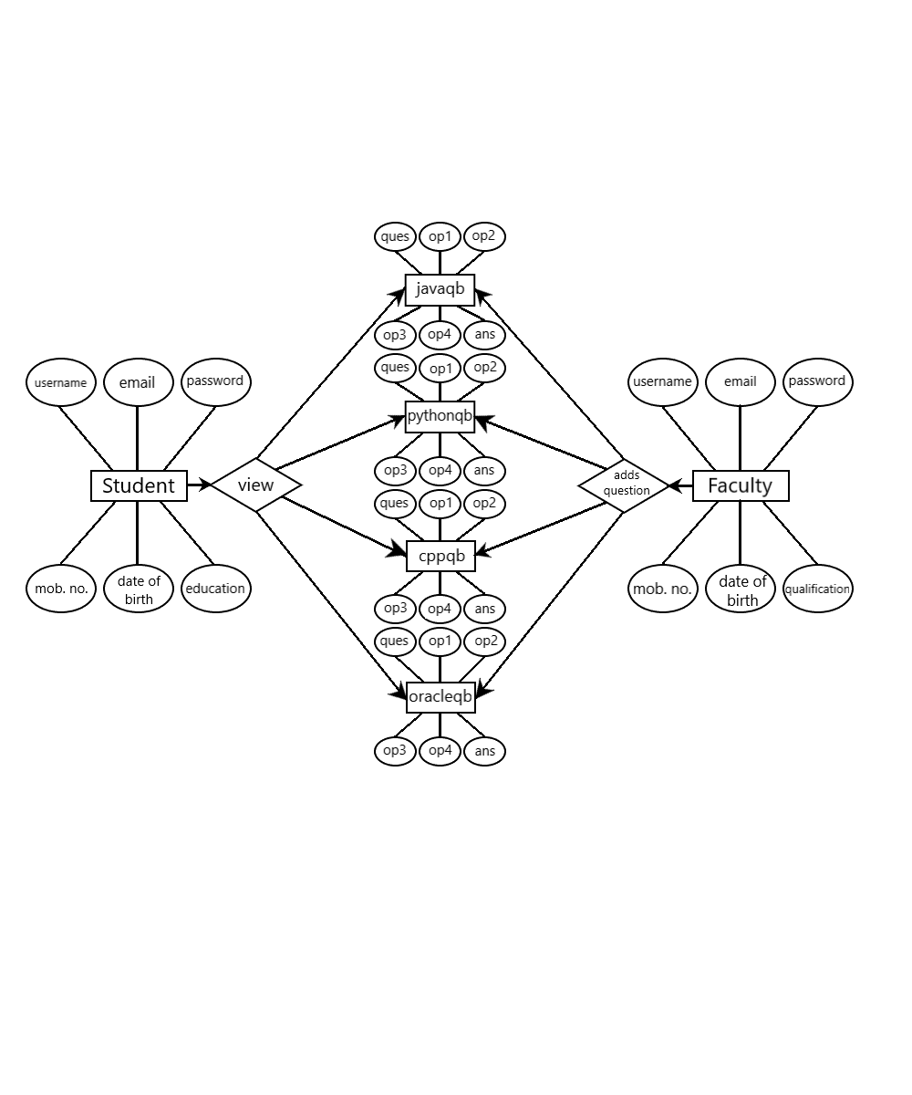**ENTITY-RELATIONSHIP DIAGRAM**

**DATA FLOW DIAGRAM**

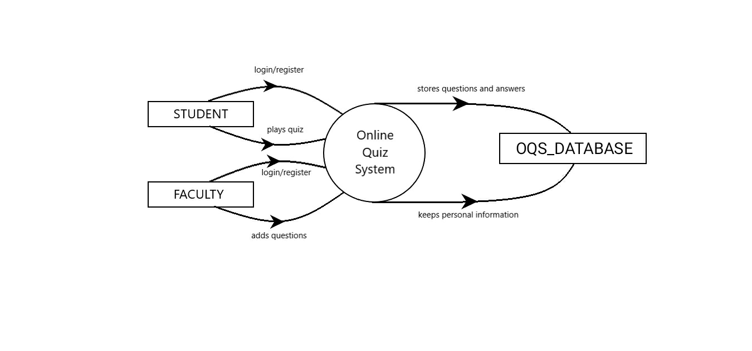**CONTEXT ANALYSIS DIAGRAM**

**DATA FLOW DIAGRAM**

**LEVEL 1 DFD FOR STUDENT**

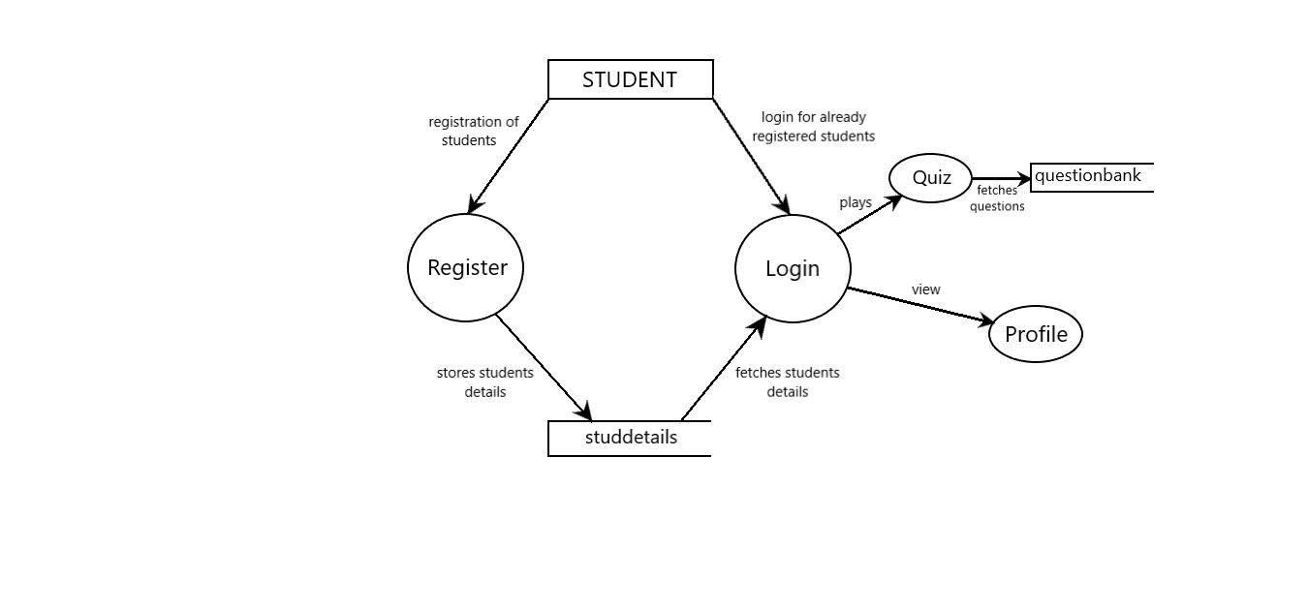

**LEVEL 1 DFD FOR FACULTY**

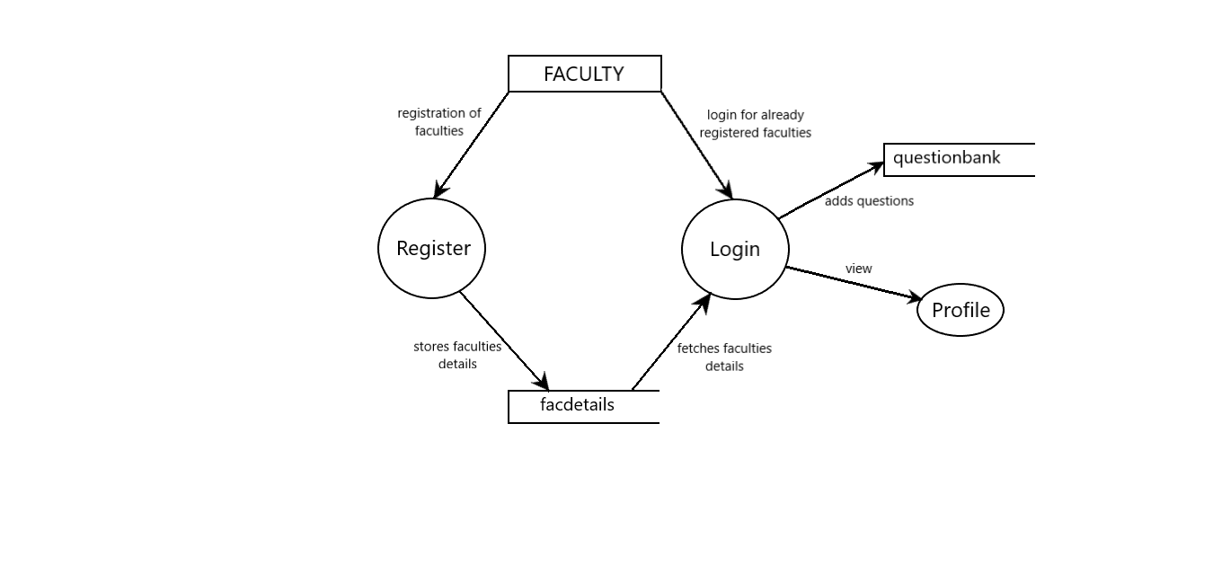

**RUNTIME WINDOWS**

**HOME**

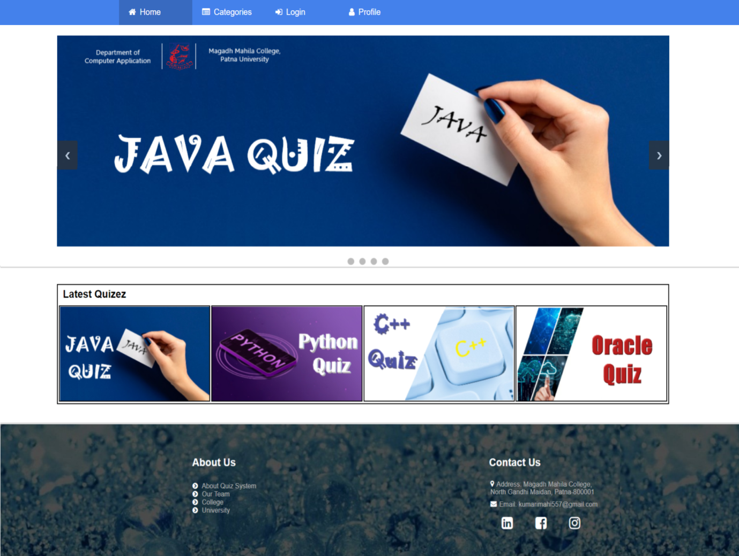

**TEACHER’S LOGIN**

**SIGN IN**

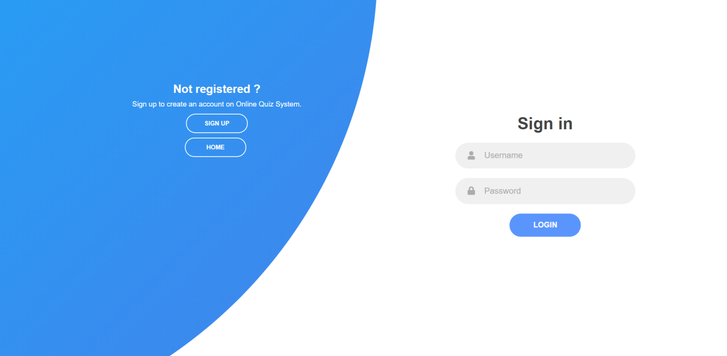

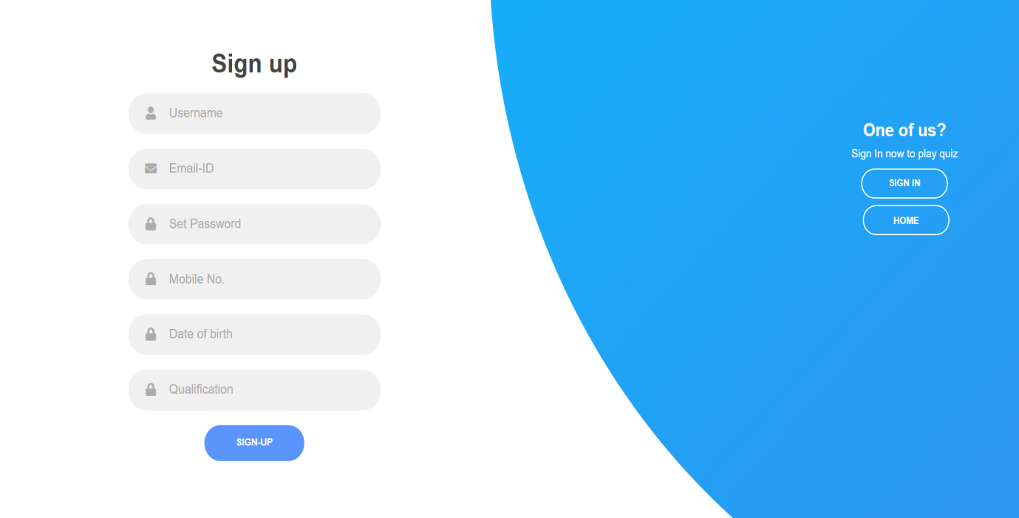**SIGN UP**

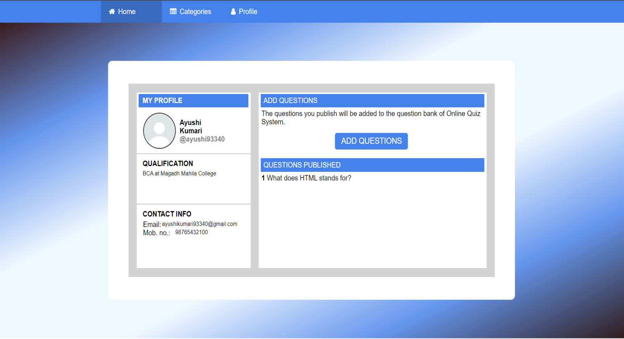**TEACHER’S PROFILE**

**ADD QUESTION**

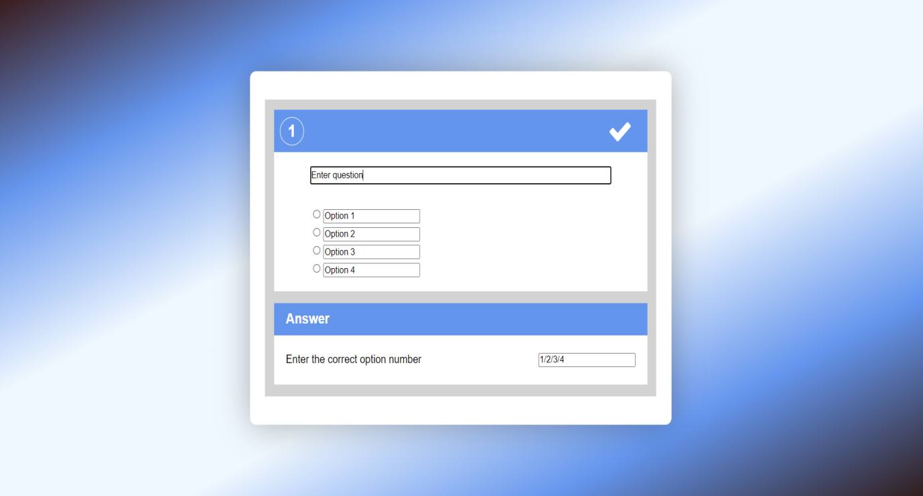

**STUDENT’S LOGIN**

**SIGN IN**

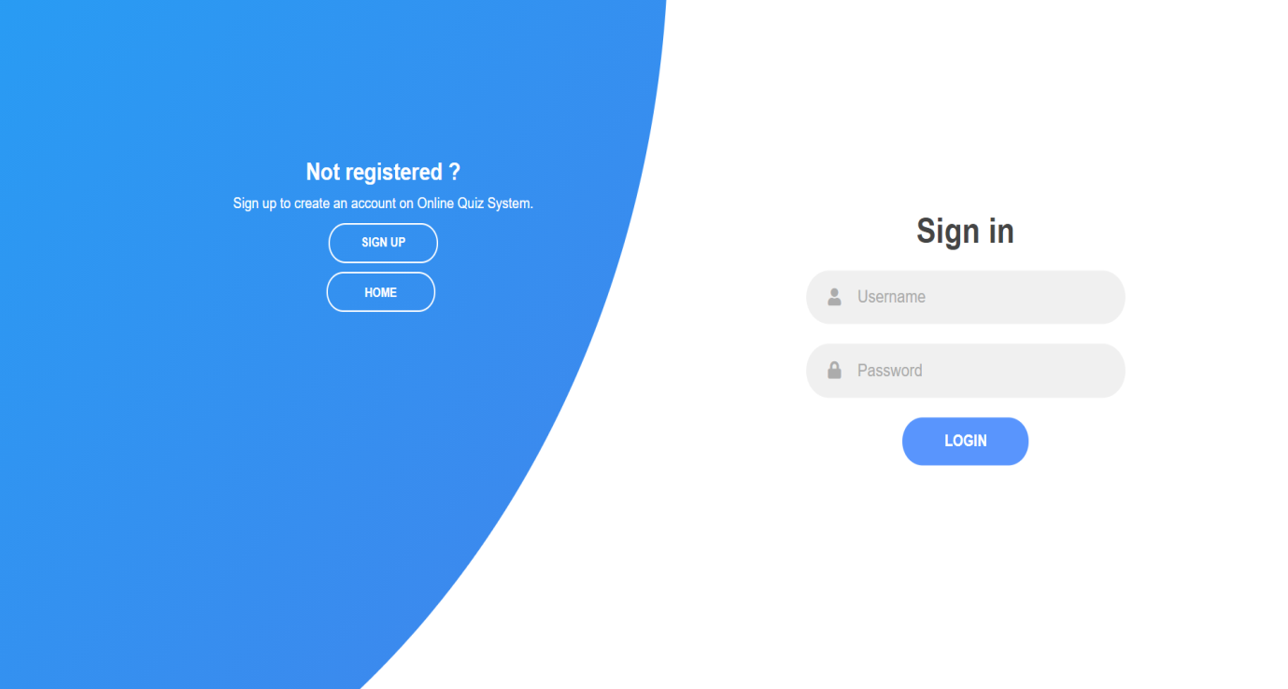

**SIGN UP**

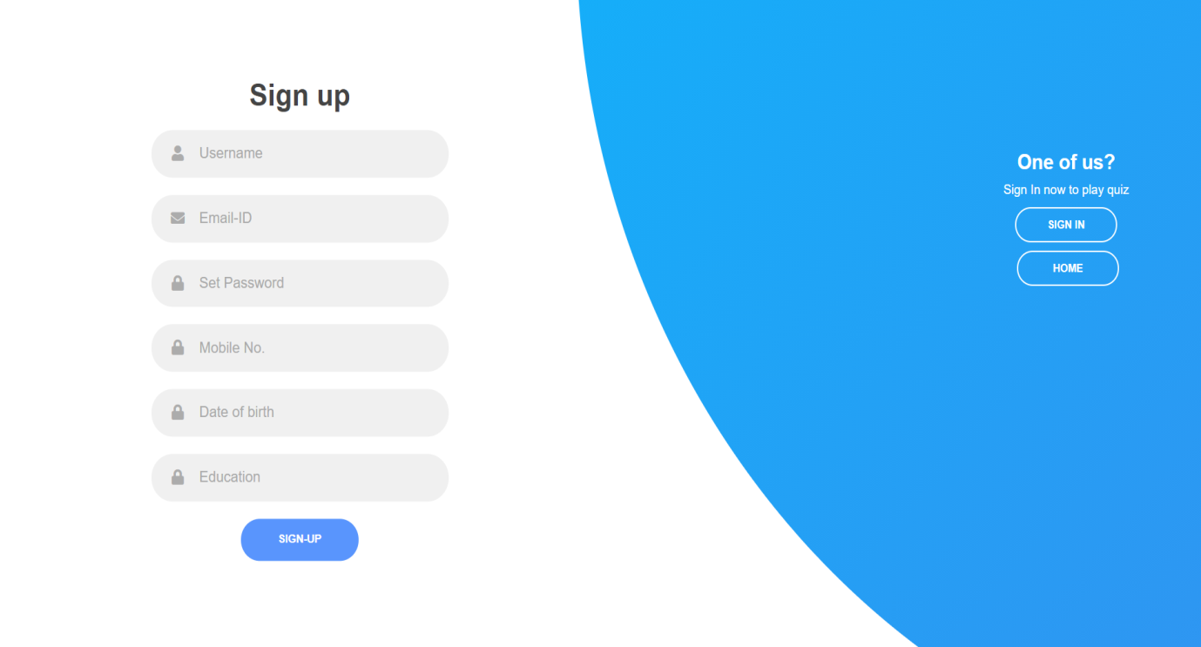

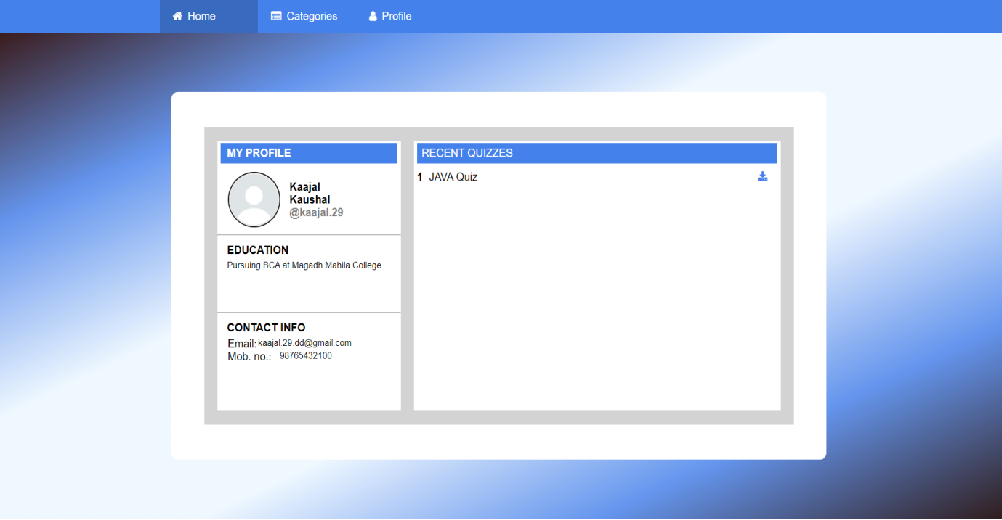**STUDENT’S PROFILE**

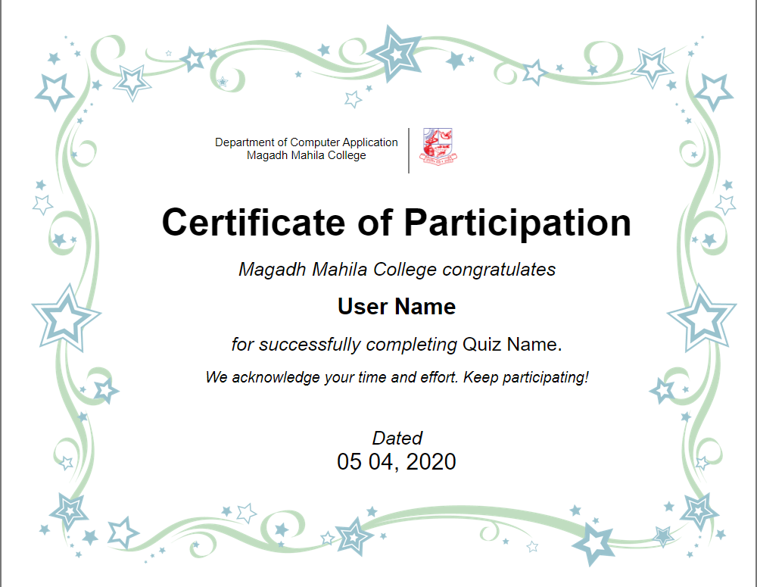**CERTIFICATE**

**PLAY QUIZ**

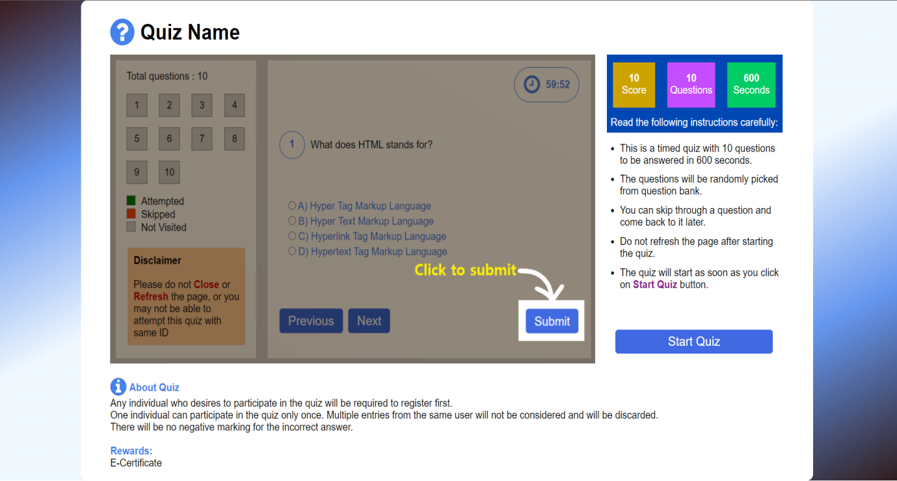**INFO**

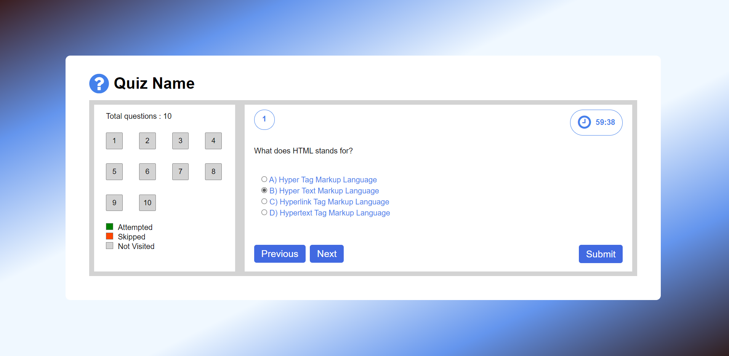**PLAY**

**CODES**

**Meta-inf**

**Content.xml**

**<?xml version="1.0" encoding="UTF-8"?>**

**<Context antiJARLocking="true" path="/Online_Quiz_System"/>**

**Web-inf**

**Web.xml**

**<?xml version="1.0" encoding="UTF-8"?>**

**<web-app version="3.1" xmlns="http://xmlns.jcp.org/xml/ns/javaee" xmlns:xsi="http://www.w3.org/2001/XMLSchema-instance" xsi:schemaLocation="http://xmlns.jcp.org/xml/ns/javaee http://xmlns.jcp.org/xml/ns/javaee/web-app_3_1.xsd">**

**<servlet>**

**<servlet-name>studservlet</servlet-name>**

**<servlet-class>studpackage.studservlet</servlet-class>**

**</servlet>**

**<servlet>**

**<servlet-name>studregister</servlet-name>**

**<servlet-class>studpackage.studregister</servlet-class>**

**</servlet>**

**<servlet>**

**<servlet-name>RegisterServlet</servlet-name>**

**<servlet-class>studpackage.RegisterServlet</servlet-class>**

**</servlet>**

**<servlet>**

**<servlet-name>LoginServlet</servlet-name>**

**<servlet-class>studpackage.LoginServlet</servlet-class>**

**</servlet>**

**<servlet>**

**<servlet-name>TLoginServlet</servlet-name>**

**<servlet-class>tpackage.TLoginServlet</servlet-class>**

**</servlet>**

**<servlet>**

**<servlet-name>TRegisterServlet</servlet-name>**

**<servlet-class>tpackage.TRegisterServlet</servlet-class>**

**</servlet>**

**<servlet>**

**<servlet-name>AddServlet</servlet-name>**

**<servlet-class>cpppackage.AddServlet</servlet-class>**

**</servlet>**

**<servlet>**

**<servlet-name>ShowServlet</servlet-name>**

**<servlet-class>cpppackage.ShowServlet</servlet-class>**

**</servlet>**

**<servlet>**

**<servlet-name>JavaServlet</servlet-name>**

**<servlet-class>javapackage.JavaServlet</servlet-class>**

**</servlet>**

**<servlet>**

**<servlet-name>OracleServlet</servlet-name>**

**<servlet-class>oraclepackage.OracleServlet</servlet-class>**

**</servlet>**

**<servlet>**

**<servlet-name>PythonServlet</servlet-name>**

**<servlet-class>pythonpackage.PythonServlet</servlet-class>**

**</servlet>**

**<servlet-mapping>**

**<servlet-name>studservlet</servlet-name>**

**<url-pattern>/studservlet</url-pattern>**

**</servlet-mapping>**

**<servlet-mapping>**

**<servlet-name>studregister</servlet-name>**

**<url-pattern>/studregister</url-pattern>**

**</servlet-mapping>**

**<servlet-mapping>**

**<servlet-name>RegisterServlet</servlet-name>**

**<url-pattern>/RegisterServlet</url-pattern>**

**</servlet-mapping>**

**<servlet-mapping>**

**<servlet-name>LoginServlet</servlet-name>**

**<url-pattern>/LoginServlet</url-pattern>**

**</servlet-mapping>**

**<servlet-mapping>**

**<servlet-name>TLoginServlet</servlet-name>**

**<url-pattern>/TLoginServlet</url-pattern>**

**</servlet-mapping>**

**<servlet-mapping>**

**<servlet-name>TRegisterServlet</servlet-name>**

**<url-pattern>/TRegisterServlet</url-pattern>**

**</servlet-mapping>**

**<servlet-mapping>**

**<servlet-name>AddServlet</servlet-name>**

**<url-pattern>/AddServlet</url-pattern>**

**</servlet-mapping>**

**<servlet-mapping>**

**<servlet-name>ShowServlet</servlet-name>**

**<url-pattern>/ShowServlet</url-pattern>**

**</servlet-mapping>**

**<servlet-mapping>**

**<servlet-name>JavaServlet</servlet-name>**

**<url-pattern>/JavaServlet</url-pattern>**

**</servlet-mapping>**

**<servlet-mapping>**

**<servlet-name>OracleServlet</servlet-name>**

**<url-pattern>/OracleServlet</url-pattern>**

**</servlet-mapping>**

**<servlet-mapping>**

**<servlet-name>PythonServlet</servlet-name>**

**<url-pattern>/PythonServlet</url-pattern>**

**</servlet-mapping>**

**<session-config>**

**<session-timeout>**

**30**

**</session-timeout>**

**</session-config>**

**</web-app>**

**studpackage**

**ConnectionPro.java**

**package studpackage;**

**import java.sql.*;**

**public class ConnectionPro {**

**private static Connection con;**

**public static Connection getConnection(){**

**try{**

**if(con==null){**

**Class.forName("com.mysql.jdbc.Driver");**

**con=DriverManager.getConnection("jdbc:mysql://localhost:3306/oqs_database", "root", "Kaajal@20");**

**}**

**}catch(Exception e){**

**e.printStackTrace();**

**}**

**return con;**

**}**

**}**

**Studentities.java**

**package studpackage;**

**import java.sql.*;**

**public class studentities {**

**private String uname;**

**private String email;**

**private String pass;**

**private String mob;**

**private String dob;**

**private String edu;**

**public studentities(String uname, String email, String pass, String mob, String dob, String edu) {**

**this.uname = uname;**

**this.email = email;**

**this.pass = pass;**

**this.mob = mob;**

**this.dob = dob;**

**this.edu = edu;**

**}**

**public studentities() {**

**}**

**public String getUname() {**

**return uname;**

**}**

**public void setUname(String uname) {**

**this.uname = uname;**

**}**

**public String getEmail() {**

**return email;**

**}**

**public void setEmail(String email) {**

**this.email = email;**

**}**

**public String getPass() {**

**return pass;**

**}**

**public void setPass(String pass) {**

**this.pass = pass;**

**}**

**public String getMob() {**

**return mob;**

**}**

**public void setMob(String mob) {**

**this.mob = mob;**

**}**

**public String getDob() {**

**return dob;**

**}**

**public void setDob(String dob) {**

**this.dob = dob;**

**}**

**public String getEdu() {**

**return edu;**

**}**

**public void setEdu(String edu) {**

**this.edu = edu;**

**}**

**}**

**studcon.java**

**package studpackage;**

**import java.sql.*;**

**/\*\***

**\***

**\* @author Kommal Kaushal**

**\*/**

**public class studcon {**

**private Connection con;**

**public studcon(Connection con) {**

**this.con = con;**

**}**

**public boolean saveUser(studentities stud)**

**{**

**boolean f=false;**

**try{**

**String query = "insert into studdetails(username,email,password,education,mobno,dateofbirth) values (?,?,?,?,?,?)";**

**PreparedStatement pstmt = this.con.prepareStatement(query);**

**pstmt.setString(1, stud.getUname());**

**pstmt.setString(2, stud.getEmail());**

**pstmt.setString(3, stud.getPass());**

**pstmt.setString(6, stud.getEdu());**

**pstmt.setString(5, stud.getMob());**

**pstmt.setString(4, stud.getDob());**

**pstmt.executeUpdate();**

**f=true;**

**}catch(Exception e){**

**e.printStackTrace();**

**}**

**return f;**

**}**

**public studentities getUserByEmailAndPassword(String uname, String pass){**

**studentities stud = null;**

**try{**

**String query = "select * from studdetails where username=? and password=?";**

**PreparedStatement pstmt = con.prepareStatement(query);**

**pstmt.setString(1, uname);**

**pstmt.setString(2, pass);**

**ResultSet set = pstmt.executeQuery();**

**if(set.next()){**

**stud = new studentities();**

**String name = set.getString("username");**

**stud.setUname(name);**

**stud.setEmail(set.getString("email"));**

**stud.setPass(set.getString("password"));**

**stud.setEdu(set.getString("education"));**

**stud.setMob(set.getString("mobno"));**

**stud.setDob(set.getString("dateofbirth"));**

**}**

**}catch(Exception e){**

**e.printStackTrace();**

**}**

**return stud;**

**}**

**}**

**LoginServlet.java**

**package studpackage;**

**import java.io.IOException;**

**import java.io.PrintWriter;**

**import javax.servlet.ServletException;**

**import javax.servlet.http.HttpServlet;**

**import javax.servlet.http.HttpServletRequest;**

**import javax.servlet.http.HttpServletResponse;**

**import javax.servlet.http.HttpSession;**

**/\*\***

**\***

**\* @author Kommal Kaushal**

**\*/**

**public class LoginServlet extends HttpServlet {**

**/\*\***

**\* Processes requests for both HTTP <code>GET</code> and <code>POST</code>**

**\* methods.**

**\***

**\* @param request servlet request**

**\* @param response servlet response**

**\* @throws ServletException if a servlet-specific error occurs**

**\* @throws IOException if an I/O error occurs**

**\*/**

**protected void processRequest(HttpServletRequest request, HttpServletResponse response)**

**throws ServletException, IOException {**

**response.setContentType("text/html;charset=UTF-8");**

**try (PrintWriter out = response.getWriter()) {**

**/* TODO output your page here. You may use following sample code. */**

**out.println("<!DOCTYPE html>");**

**out.println("<html>");**

**out.println("<head>");**

**out.println("<title>Servlet LoginServlet</title>");**

**out.println("</head>");**

**out.println("<body>");**

**String userName=request.getParameter("user-name");**

**String userPass=request.getParameter("pass-word");**

**studcon stu;**

**stu = new studcon(ConnectionPro.getConnection());**

**studentities studt=stu.getUserByEmailAndPassword(userName, userPass);**

**if(studt==null){**

**//error**

**out.println("User not found");**

**}else{**

**HttpSession s = request.getSession();**

**s.setAttribute("currentUser", studt);**

**response.sendRedirect("spro.jsp");**

**}**

**out.println("</body>");**

**out.println("</html>");**

**}**

**}**

**// <editor-fold defaultstate="collapsed" desc="HttpServlet methods. Click on the + sign on the left to edit the code.">**

**/\*\***

**\* Handles the HTTP <code>GET</code> method.**

**\***

**\* @param request servlet request**

**\* @param response servlet response**

**\* @throws ServletException if a servlet-specific error occurs**

**\* @throws IOException if an I/O error occurs**

**\*/**

**@Override**

**protected void doGet(HttpServletRequest request, HttpServletResponse response)**

**throws ServletException, IOException {**

**processRequest(request, response);**

**}**

**/\*\***

**\* Handles the HTTP <code>POST</code> method.**

**\***

**\* @param request servlet request**

**\* @param response servlet response**

**\* @throws ServletException if a servlet-specific error occurs**

**\* @throws IOException if an I/O error occurs**

**\*/**

**@Override**

**protected void doPost(HttpServletRequest request, HttpServletResponse response)**

**throws ServletException, IOException {**

**processRequest(request, response);**

**}**

**/\*\***

**\* Returns a short description of the servlet.**

**\***

**\* @return a String containing servlet description**

**\*/**

**@Override**

**public String getServletInfo() {**

**return "Short description";**

**}// </editor-fold>**

**}**

**RegisterServlet.java**

**package studpackage;**

**import java.io.IOException;**

**import java.io.PrintWriter;**

**import javax.servlet.ServletException;**

**import javax.servlet.http.HttpServlet;**

**import javax.servlet.http.HttpServletRequest;**

**import javax.servlet.http.HttpServletResponse;**

**/\*\***

**\***

**\* @author Kommal Kaushal**

**\*/**

**public class RegisterServlet extends HttpServlet {**

**/\*\***

**\* Processes requests for both HTTP <code>GET</code> and <code>POST</code>**

**\* methods.**

**\***

**\* @param request servlet request**

**\* @param response servlet response**

**\* @throws ServletException if a servlet-specific error occurs**

**\* @throws IOException if an I/O error occurs**

**\*/**

**protected void processRequest(HttpServletRequest request, HttpServletResponse response)**

**throws ServletException, IOException {**

**response.setContentType("text/html;charset=UTF-8");**

**try (PrintWriter out = response.getWriter()) {**

**/* TODO output your page here. You may use following sample code. */**

**out.println("<!DOCTYPE html>");**

**out.println("<html>");**

**out.println("<head>");**

**out.println("<title>Servlet RegisterServlet</title>");**

**out.println("</head>");**

**out.println("<body>");**

**//fetch all data form data**

**String uname = request.getParameter("uname");**

**String email = request.getParameter("email");**

**String pass = request.getParameter("pass");**

**String edu = request.getParameter("edu");**

**String mob = request.getParameter("mob");**

**String dob = request.getParameter("dob");**

**studentities stud=new studentities(uname,email,pass,dob,mob,edu);**

**studcon stu;**

**stu = new studcon(ConnectionPro.getConnection());**

**if(stu.saveUser(stud)){**

**// out.println("done");**

**response.sendRedirect("slogin.jsp");**

**}else{**

**out.println("error");**

**}**

**//out.println(uname);**

**out.println("</body>");**

**out.println("</html>");**

**}**

**}**

**// <editor-fold defaultstate="collapsed" desc="HttpServlet methods. Click on the + sign on the left to edit the code.">**

**/\*\***

**\* Handles the HTTP <code>GET</code> method.**

**\***

**\* @param request servlet request**

**\* @param response servlet response**

**\* @throws ServletException if a servlet-specific error occurs**

**\* @throws IOException if an I/O error occurs**

**\*/**

**@Override**

**protected void doGet(HttpServletRequest request, HttpServletResponse response)**

**throws ServletException, IOException {**

**processRequest(request, response);**

**}**

**/\*\***

**\* Handles the HTTP <code>POST</code> method.**

**\***

**\* @param request servlet request**

**\* @param response servlet response**

**\* @throws ServletException if a servlet-specific error occurs**

**\* @throws IOException if an I/O error occurs**

**\*/**

**@Override**

**protected void doPost(HttpServletRequest request, HttpServletResponse response)**

**throws ServletException, IOException {**

**processRequest(request, response);**

**}**

**/\*\***

**\* Returns a short description of the servlet.**

**\***

**\* @return a String containing servlet description**

**\*/**

**@Override**

**public String getServletInfo() {**

**return "Short description";**

**}// </editor-fold>**

**}**

**tpackage**

**TConnectionPro.java**

**package tpackage;**

**import java.sql.*;**

**/\*\***

**\***

**\* @author Kommal Kaushal**

**\*/**

**public class TConnectionPro {**

**private static Connection con;**

**public static Connection getConnection(){**

**try{**

**if(con==null){**

**Class.forName("com.mysql.jdbc.Driver");**

**con=DriverManager.getConnection("jdbc:mysql://localhost:3306/oqs_database", "root", "Kaajal@20");**

**}**

**}catch(Exception e){**

**e.printStackTrace();**

**}**

**return con;**

**}**

**}**

**facentities.java**

**package tpackage;**

**import java.sql.*;**

**/\*\***

**\***

**\* @author Kommal Kaushal**

**\*/**

**public class facentities {**

**private String tuname;**

**private String temail;**

**private String tpass;**

**private String tmob;**

**private String tdob;**

**private String tedu;**

**public facentities(String tuname, String temail, String tpass, String tmob, String tdob, String tedu) {**

**this.tuname = tuname;**

**this.temail = temail;**

**this.tpass = tpass;**

**this.tmob = tmob;**

**this.tdob = tdob;**

**this.tedu = tedu;**

**}**

**public facentities() {**

**}**

**public String getTuname() {**

**return tuname;**

**}**

**public void setTuname(String tuname) {**

**this.tuname = tuname;**

**}**

**public String getTemail() {**

**return temail;**

**}**

**public void setTemail(String temail) {**

**this.temail = temail;**

**}**

**public String getTpass() {**

**return tpass;**

**}**

**public void setTpass(String tpass) {**

**this.tpass = tpass;**

**}**

**public String getTmob() {**

**return tmob;**

**}**

**public void setTmob(String tmob) {**

**this.tmob = tmob;**

**}**

**public String getTdob() {**

**return tdob;**

**}**

**public void setTdob(String tdob) {**

**this.tdob = tdob;**

**}**

**public String getTedu() {**

**return tedu;**

**}**

**public void setTedu(String tedu) {**

**this.tedu = tedu;**

**}**

**}**

**faccon.java**

**package tpackage;**

**import java.sql.*;**

**/\*\***

**\***

**\* @author Kommal Kaushal**

**\*/**

**public class faccon {**

**private Connection con;**

**public faccon(Connection con) {**

**this.con = con;**

**}**

**public boolean saveUser(facentities fac)**

**{**

**boolean f=false;**

**try{**

**String query = "insert into facdetails(username,email,password,mobno,dateofbirth,qualification) values (?,?,?,?,?,?)";**

**PreparedStatement pstmt = this.con.prepareStatement(query);**

**pstmt.setString(1, fac.getTuname());**

**pstmt.setString(2, fac.getTemail());**

**pstmt.setString(3, fac.getTpass());**

**pstmt.setString(5, fac.getTmob());**

**pstmt.setString(4, fac.getTdob());**

**pstmt.setString(6, fac.getTedu());**

**pstmt.executeUpdate();**

**f=true;**

**}catch(Exception e){**

**e.printStackTrace();**

**}**

**return f;**

**}**

**public facentities getUserByEmailAndPassword(String tuname, String tpass){**

**facentities fac = null;**

**try{**

**String query = "select * from facdetails where username=? and password=?";**

**PreparedStatement pstmt = con.prepareStatement(query);**

**pstmt.setString(1, tuname);**

**pstmt.setString(2, tpass);**

**ResultSet set = pstmt.executeQuery();**

**if(set.next()){**

**fac = new facentities();**

**String name = set.getString("username");**

**fac.setTuname(name);**

**fac.setTemail(set.getString("email"));**

**fac.setTpass(set.getString("password"));**

**fac.setTedu(set.getString("qualification"));**

**fac.setTmob(set.getString("mobno"));**

**fac.setTdob(set.getString("dateofbirth"));**

**}**

**}catch(Exception e){**

**e.printStackTrace();**

**}**

**return fac;**

**}**

**}**

**TRegisterServlet.java**

**package tpackage;**

**import java.io.IOException;**

**import java.io.PrintWriter;**

**import javax.servlet.ServletException;**

**import javax.servlet.http.HttpServlet;**

**import javax.servlet.http.HttpServletRequest;**

**import javax.servlet.http.HttpServletResponse;**

**/\*\***

**\***

**\* @author Kommal Kaushal**

**\*/**

**public class TRegisterServlet extends HttpServlet {**

**/\*\***

**\* Processes requests for both HTTP <code>GET</code> and <code>POST</code>**

**\* methods.**

**\***

**\* @param request servlet request**

**\* @param response servlet response**

**\* @throws ServletException if a servlet-specific error occurs**

**\* @throws IOException if an I/O error occurs**

**\*/**

**protected void processRequest(HttpServletRequest request, HttpServletResponse response)**

**throws ServletException, IOException {**

**response.setContentType("text/html;charset=UTF-8");**

**try (PrintWriter out = response.getWriter()) {**

**/* TODO output your page here. You may use following sample code. */**

**out.println("<!DOCTYPE html>");**

**out.println("<html>");**

**out.println("<head>");**

**out.println("<title>Servlet TRegisterServlet</title>");**

**out.println("</head>");**

**out.println("<body>");**

**//fetch all data form data**

**String tuname = request.getParameter("tuname");**

**String temail = request.getParameter("temail");**

**String tpass = request.getParameter("tpass");**

**String tedu = request.getParameter("tedu");**

**String tmob = request.getParameter("tmob");**

**String tdob = request.getParameter("tdob");**

**facentities fac=new facentities(tuname,temail,tpass,tdob,tmob,tedu);**

**faccon fa;**

**fa = new faccon(TConnectionPro.getConnection());**

**if(fa.saveUser(fac)){**

**// out.println("done");**

**response.sendRedirect("tlogin.jsp");**

**}else{**

**out.println("error");**

**}**

**out.println("</body>");**

**out.println("</html>");**

**}**

**}**

**// <editor-fold defaultstate="collapsed" desc="HttpServlet methods. Click on the + sign on the left to edit the code.">**

**/\*\***

**\* Handles the HTTP <code>GET</code> method.**

**\***

**\* @param request servlet request**

**\* @param response servlet response**

**\* @throws ServletException if a servlet-specific error occurs**

**\* @throws IOException if an I/O error occurs**

**\*/**

**@Override**

**protected void doGet(HttpServletRequest request, HttpServletResponse response)**

**throws ServletException, IOException {**

**processRequest(request, response);**

**}**

**/\*\***

**\* Handles the HTTP <code>POST</code> method.**

**\***

**\* @param request servlet request**

**\* @param response servlet response**

**\* @throws ServletException if a servlet-specific error occurs**

**\* @throws IOException if an I/O error occurs**

**\*/**

**@Override**

**protected void doPost(HttpServletRequest request, HttpServletResponse response)**

**throws ServletException, IOException {**

**processRequest(request, response);**

**}**

**/\*\***

**\* Returns a short description of the servlet.**

**\***

**\* @return a String containing servlet description**

**\*/**

**@Override**

**public String getServletInfo() {**

**return "Short description";**

**}// </editor-fold>**

**}**

**TLoginServlet.java**

**package tpackage;**

**import java.io.IOException;**

**import java.io.PrintWriter;**

**import javax.servlet.ServletException;**

**import javax.servlet.http.HttpServlet;**

**import javax.servlet.http.HttpServletRequest;**

**import javax.servlet.http.HttpServletResponse;**

**import javax.servlet.http.HttpSession;**

**/\*\***

**\***

**\* @author Kommal Kaushal**

**\*/**

**public class TLoginServlet extends HttpServlet {**

**/\*\***

**\* Processes requests for both HTTP <code>GET</code> and <code>POST</code>**

**\* methods.**

**\***

**\* @param request servlet request**

**\* @param response servlet response**

**\* @throws ServletException if a servlet-specific error occurs**

**\* @throws IOException if an I/O error occurs**

**\*/**

**protected void processRequest(HttpServletRequest request, HttpServletResponse response)**

**throws ServletException, IOException {**

**response.setContentType("text/html;charset=UTF-8");**

**try (PrintWriter out = response.getWriter()) {**

**/* TODO output your page here. You may use following sample code. */**

**out.println("<!DOCTYPE html>");**

**out.println("<html>");**

**out.println("<head>");**

**out.println("<title>Servlet TLoginServlet</title>");**

**out.println("</head>");**

**out.println("<body>");**

**String usertName=request.getParameter("user-tname");**

**String usertPass=request.getParameter("pass-tword");**

**faccon fa;**

**fa = new faccon(TConnectionPro.getConnection());**

**facentities fact=fa.getUserByEmailAndPassword(usertName, usertPass);**

**if(fact==null){**

**//error**

**out.println("User not found");**

**}else{**

**HttpSession s = request.getSession();**

**s.setAttribute("currentUser", fact);**

**response.sendRedirect("tpro.jsp");**

**}**

**out.println("</body>");**

**out.println("</html>");**

**}**

**}**

**// <editor-fold defaultstate="collapsed" desc="HttpServlet methods. Click on the + sign on the left to edit the code.">**

**/\*\***

**\* Handles the HTTP <code>GET</code> method.**

**\***

**\* @param request servlet request**

**\* @param response servlet response**

**\* @throws ServletException if a servlet-specific error occurs**

**\* @throws IOException if an I/O error occurs**

**\*/**

**@Override**

**protected void doGet(HttpServletRequest request, HttpServletResponse response)**

**throws ServletException, IOException {**

**processRequest(request, response);**

**}**

**/\*\***

**\* Handles the HTTP <code>POST</code> method.**

**\***

**\* @param request servlet request**

**\* @param response servlet response**

**\* @throws ServletException if a servlet-specific error occurs**

**\* @throws IOException if an I/O error occurs**

**\*/**

**@Override**

**protected void doPost(HttpServletRequest request, HttpServletResponse response)**

**throws ServletException, IOException {**

**processRequest(request, response);**

**}**

**/\*\***

**\* Returns a short description of the servlet.**

**\***

**\* @return a String containing servlet description**

**\*/**

**@Override**

**public String getServletInfo() {**

**return "Short description";**

**}// </editor-fold>**

**}**

**Cpppackage**

**CConnectionPro.java**

**package cpppackage;**

**import java.sql.*;**

**/\*\***

**\***

**\* @author Kommal Kaushal**

**\*/**

**public class CConnectionPro {**

**private static Connection con;**

**public static Connection getConnection(){**

**try{**

**if(con==null){**

**Class.forName("com.mysql.jdbc.Driver");**

**con=DriverManager.getConnection("jdbc:mysql://localhost:3306/oqs_database", "root", "Kaajal@20");**

**}**

**}catch(Exception e){**

**e.printStackTrace();**

**}**

**return con;**

**}**

**}**

**Cppentities.java**

**package cpppackage;**

**import java.sql.*;**

**/\*\***

**\***

**\* @author Kommal Kaushal**

**\*/**

**public class cppentities {**

**private int sno;**

**private String quest;**

**private String opn1;**

**private String opn2;**

**private String opn3;**

**private String opn4;**

**private String ans;**

**public cppentities(int sno, String quest, String opn1, String opn2, String opn3, String opn4, String ans) {**

**this.sno = sno;**

**this.quest = quest;**

**this.opn1 = opn1;**

**this.opn2 = opn2;**

**this.opn3 = opn3;**

**this.opn4 = opn4;**

**this.ans = ans;**

**}**

**public cppentities() {**

**}**

**public int getSno() {**

**return sno;**

**}**

**public void setSno(int sno) {**

**this.sno = sno;**

**}**

**public String getQuest() {**

**return quest;**

**}**

**public void setQuest(String quest) {**

**this.quest = quest;**

**}**

**public String getOpn1() {**

**return opn1;**

**}**

**public void setOpn1(String opn1) {**

**this.opn1 = opn1;**

**}**

**Cppcon.java**

**package cpppackage;**

**import java.sql.*;**

**/\*\***

**\***

**\* @author Kommal Kaushal**

**\*/**

**public class cppcon {**

**private Connection con;**

**public cppcon(Connection con) {**

**this.con = con;**

**}**

**public boolean saveUser(cppentities cpp)**

**{**

**boolean f=false;**

**try{**

**String query = "insert into cppqb(op1, op2, op3, op4, ans, ques) values (?,?,?,?,?,?)";**

**PreparedStatement pstmt = this.con.prepareStatement(query);**

**pstmt.setString(1, cpp.getOpn1());**

**pstmt.setString(2, cpp.getOpn2());**

**pstmt.setString(3, cpp.getOpn3());**

**pstmt.setString(4, cpp.getOpn4());**

**pstmt.setString(5, cpp.getAns());**

**pstmt.setString(6, cpp.getQuest());**

**pstmt.executeUpdate();**

**f=true;**

**}catch(Exception e){**

**e.printStackTrace();**

**}**

**return f;**

**}**

**}**

**AddServlet.java**

**package cpppackage;**

**import java.io.IOException;**

**import java.io.PrintWriter;**

**import javax.servlet.ServletException;**

**import javax.servlet.http.HttpServlet;**

**import javax.servlet.http.HttpServletRequest;**

**import javax.servlet.http.HttpServletResponse;**

**/\*\***

**\***

**\* @author Kommal Kaushal**

**\*/**

**public class AddServlet extends HttpServlet {**

**/\*\***

**\* Processes requests for both HTTP <code>GET</code> and <code>POST</code>**

**\* methods.**

**\***

**\* @param request servlet request**

**\* @param response servlet response**

**\* @throws ServletException if a servlet-specific error occurs**

**\* @throws IOException if an I/O error occurs**

**\*/**

**protected void processRequest(HttpServletRequest request, HttpServletResponse response)**

**throws ServletException, IOException {**

**response.setContentType("text/html;charset=UTF-8");**

**try (PrintWriter out = response.getWriter()) {**

**/* TODO output your page here. You may use following sample code. */**

**out.println("<!DOCTYPE html>");**

**out.println("<html>");**

**out.println("<head>");**

**out.println("<title>Servlet AddServlet</title>");**

**out.println("</head>");**

**out.println("<body>");**

**//fetch all data form data**

**String opn1 = request.getParameter("opn1");**

**String opn2 = request.getParameter("opn2");**

**String opn3 = request.getParameter("opn3");**

**String opn4 = request.getParameter("opn4");**

**String ans = request.getParameter("ans");**

**String quest = request.getParameter("quest");**

**cppentities cpp=new cppentities(quest,opn1,opn2,opn3,opn4,ans);**

**cppcon ca;**

**ca = new cppcon(CConnectionPro.getConnection());**

**if(ca.saveUser(cpp)){**

**// out.println("done");**

**response.sendRedirect("addques.jsp");**

**}else{**

**out.println("error");**

**}**

**out.println("</body>");**

**out.println("</html>");**

**}**

**}**

**// <editor-fold defaultstate="collapsed" desc="HttpServlet methods. Click on the + sign on the left to edit the code.">**

**/\*\***

**\* Handles the HTTP <code>GET</code> method.**

**\***

**\* @param request servlet request**

**\* @param response servlet response**

**\* @throws ServletException if a servlet-specific error occurs**

**\* @throws IOException if an I/O error occurs**

**\*/**

**@Override**

**protected void doGet(HttpServletRequest request, HttpServletResponse response)**

**throws ServletException, IOException {**

**processRequest(request, response);**

**}**

**/\*\***

**\* Handles the HTTP <code>POST</code> method.**

**\***

**\* @param request servlet request**

**\* @param response servlet response**

**\* @throws ServletException if a servlet-specific error occurs**

**\* @throws IOException if an I/O error occurs**

**\*/**

**@Override**

**protected void doPost(HttpServletRequest request, HttpServletResponse response)**

**throws ServletException, IOException {**

**processRequest(request, response);**

**}**

**/\*\***

**\* Returns a short description of the servlet.**

**\***

**\* @return a String containing servlet description**

**\*/**

**@Override**

**public String getServletInfo() {**

**return "Short description";**

**}// </editor-fold>**

**}**

**Style.css**

**\*{**

**padding: 0;**

**margin: 0;**

**box-sizing: border-box;**

**}**

**body, input{**

**font-family: sans-serif;**

**align-items: center;**

**justify-content: center;**

**}**

**.main{**

**align-items: center;**

**text-align: center;**

**}**

**h1{**

**text-align: center;**

**}**

**.mmclogo{**

**width: 50px;**

**height: 50px;**

**}**

**.menu-bar{**

**background: #4481eb;**

**text-align: left;**

**}**

**.menu-bar ul{**

**display: inline-flex;**

**list-style: none;**

**color: white;**

**margin-left: 250px;**

**}**

**.menu-bar ul li{**

**width: 150px;**

**padding: 15px 20px;**

**}**

**.menu-bar ul li a{**

**text-decoration: none;**

**color: white;**

**}**

**.active, .menu-bar ul li:hover{**

**background: #386ac0;**

**/*rgb(0, 0, 51)*/**

**}**

**.active, .menu-bar ul li a:hover{**

**color: rgb(0, 0, 51);**

**}**

**.menu-bar .fa{**

**margin-right: 8px;**

**}**

**.sub-menu-1{**

**display: none;**

**}**

**.menu-bar ul li:hover .sub-menu-1{**

**display: block;**

**position: absolute;**

**background: #4481eb;**

**margin-top: 15px;**

**margin-left: -15px;**

**}**

**.menu-bar ul li:hover .sub-menu-1 ul{**

**display: block;**

**margin: 10px;**

**}**

**.menu-bar ul li:hover .sub-menu-1 ul li{**

**width: 150px;**

**padding: 10px;**

**border-bottom: 1px dotted #fff;**

**background: transparent;**

**border-radius: 0;**

**text-align: left;**

**}**

**.menu-bar ul li:hover .sub-menu-1 ul li:last-child{**

**border-bottom: none;**

**}**

**.menu-bar ul li:hover .sub-menu-1 ul li a{**

**width: 150px;**

**padding: 10px;**

**}**

**.menu-bar ul li:hover .sub-menu-1 ul li a:hover{**

**color: rgb(0, 0, 51);**

**}**

**.menu-bar ul input[type=text] {**

**float: right;**

**border: none;**

**width: 100px;**

**font-size: 15px;**

**}**

**@media screen and (max-width: 600px) {**

**.menu-bar ul input[type=text] {**

**float: none;**

**display: block;**

**text-align: left;**

**width: 100%;**

**margin: 0;**

**padding: 14px;**

**}**

**.menu-bar ul input[type=text] {**

**border: 1px solid #ccc;**

**}**

**}**

**.sub-menu-2{**

**display: none;**

**}**

**.menu-bar ul li:hover .sub-menu-2{**

**display: block;**

**position: absolute;**

**background: #4481eb;**

**margin-top: 15px;**

**margin-left: -15px;**

**}**

**.menu-bar ul li:hover .sub-menu-2 ul{**

**display: block;**

**margin: 10px;**

**}**

**.menu-bar ul li:hover .sub-menu-2 ul li{**

**width: 150px;**

**padding: 10px;**

**border-bottom: 1px dotted #fff;**

**background: transparent;**

**border-radius: 0;**

**text-align: left;**

**}**

**.menu-bar ul li:hover .sub-menu-2 ul li:last-child{**

**border-bottom: none;**

**}**

**.menu-bar ul li:hover .sub-menu-1 ul li a{**

**width: 150px;**

**padding: 5px;**

**}**

**.menu-bar ul li:hover .sub-menu-2 ul li a:hover{**

**color: rgb(0, 0, 51);**

**}**

**.search-bar{**

**display: flex;**

**}**

**.search-bar-txt-box{**

**width: auto;**

**}**

**.search-button{**

**margin-top: -1px;**

**}**

**.search-button .fa{**

**margin-left: 2px;**

**}**

**.container{**

**position: relative;**

**width: 100%;**

**min-height: 100vh;**

**background-color: #fff;**

**overflow: hidden;**

**}**

**.container:before{**

**content: '';**

**position: absolute;**

**width: 2000px;**

**height: 2000px;**

**border-radius: 50%;**

**background: linear-gradient(-45deg, #4481eb, #04befe);**

**top: -10%;**

**right: 48%;**

**transform: translateY(-50%);**

**z-index: 6;**

**transition: 1.8s ease-in-out;**

**}**

**.forms-container{**

**position: absolute;**

**width: 100%;**

**height: 100%;**

**top: 0;**

**left: 0;**

**}**

**.signin-signup{**

**position: absolute;**

**top: 50%;**

**left: 75%;**

**transform: translate(-50%,-50%);**

**width: 50%;**

**display: grid;**

**grid-template-columns: 1fr;**

**z-index: 5;**

**transition: 1s 0.7s ease-in-out;**

**}**

**form{**

**display: flex;**

**align-items: center;**

**justify-content: center;**

**flex-direction: column;**

**padding: 0 5rem;**

**overflow: hidden;**

**grid-column: 1 / 2;**

**grid-row: 1 / 2;**

**transition: 0.2s 0.7s ease-in-out;**

**}**

**form.sign-in-form{**

**z-index: 2;**

**}**

**form.sign-up-form{**

**z-index: 1;**

**opacity: 0;**

**}**

**.title{**

**font-size: 2.2rem;**

**color: #444;**

**margin-bottom: 10px;**

**}**

**.input-field{**

**max-width: 380px;**

**width: 100%;**

**height: 55px;**

**background-color: #f0f0f0;**

**margin: 10px 0;**

**border-radius: 55px;**

**display: grid;**

**grid-template-columns: 15% 85%;**

**padding: 0 .4rem;**

**}**

**.input-field i{**

**text-align: center;**

**line-height: 55px;**

**color: #acacac;**

**font-size: 1.1rem;**

**}**

**.input-field input{**

**background: none;**

**outline: none;**

**border: none;**

**line-height: 1;**

**font-weight: 600;**

**font-size: 1.1rem;**

**color: #333;**

**}**

**.input-field input::placeholder{**

**color: #aaa;**

**font-weight: 500;**

**}**

**.btn{**

**width: 150px;**

**height: 49px;**

**border: none;**

**outline: none;**

**border-radius: 49px;**

**cursor: pointer;**

**background-color: #5995fd;**

**color: #fff;**

**text-transform: uppercase;**

**font-weight: 600;**

**margin: 10px 0;**

**transition: .5s;**

**}**

**#login{**

**text-decoration: none;**

**padding: 15px 50px;**

**}**

**.btn:hover{**

**background-color: #4d84e2;**

**}**

**.home{**

**border-radius: 49px;**

**margin-top: 9px;**

**margin-left: 38%;**

**text-decoration: none;**

**padding: 12px;**

**display: flow-root;**

**color: white;**

**width: 130px;**

**height: 41px;**

**justify-content: center;**

**border: 2px solid white;**

**font-weight: 600;**

**font-size: 0.8rem;**

**text-transform: uppercase;**

**}**

**.social-text{**

**padding: .7rem 0;**

**font-size: 1rem;**

**}**

**.social-media{**

**display: flex;**

**justify-content: center;**

**}**

**.social-icon{**

**height: 46px;**

**width: 46px;**

**border: 1px solid #333;**

**margin: 0 0.45rem;**

**display: flex;**

**justify-content: center;**

**align-items: center;**

**text-decoration: none;**

**color: #333;**

**font-size: 1.1rem;**

**border-radius: 50%;**

**transition: .3s;**

**}**

**.social-icon:hover{**

**color: #4481eb;**

**border-color: black;**

**}**

**.panels-container{**

**position: absolute;**

**width: 100%;**

**height: 100%;**

**top: 0;**

**left: 0;**

**background-color: #fff;**

**display: grid;**

**grid-template-columns: repeat(2, 1fr);**

**}**

**.panel{**

**display: flex;**

**flex-direction: column;**

**align-items: flex-end;**

**justify-content: space-around;**

**text-align: center;**

**z-index: 7;**

**}**

**.left-panel{**

**pointer-events: all;**

**padding: 3rem 17% 2rem 12%;**

**}**

**.right-panel{**

**pointer-events: none;**

**padding: 3rem 12% 2rem 17%;**

**}**

**.panel .content{**

**color: #fff;**

**transition: .9s .6s ease-in-out;**

**}**

**.panel h3{**

**font-weight: 600;**

**line-height: 1;**

**font-size: 1.5rem;**

**}**

**.panel p{**

**font-size: 0.95rem;**

**padding: 0.7rem 0;**

**}**

**.btn.transparent{**

**margin: 0;**

**background: none;**

**border: 2px solid #fff;**

**width: 130px;**

**height: 41px;**

**font-weight: 600;**

**font-size: 0.8rem;**

**}**

**.image{**

**width: 100%;**

**transition: 1.1s .4s ease-in-out;**

**}**

**.right-panel .content, .right-panel .image{**

**transform: translateX(800px);**

**}**

**.container.sign-up-mode:before{**

**transform: translate(100%, -50%);**

**right: 52%;**

**}**

**.container.sign-up-mode .left-panel .image,**

**.container.sign-up-mode .left-panel .content{**

**transform: translateX(-800px);**

**}**

**.container.sign-up-mode .right-panel .content,**

**.container.sign-up-mode .right-panel .image{**

**transform: translateX(0px);**

**}**

**.container.sign-up-mode .left-panel{**

**pointer-events: none;**

**}**

**.container.sign-up-mode .right-panel{**

**pointer-events: all;**

**}**

**.container.sign-up-mode .signin-signup{**

**left: 25%;**

**}**

**.container.sign-up-mode form.sign-in-form{**

**z-index: 1;**

**opacity: 0;**

**}**

**.container.sign-up-mode form.sign-up-form{**

**z-index: 2;**

**opacity: 1;**

**}**

**@media (max-width: 870px){**

**.container{**

**min-height: 800px;**

**height: 100vh;**

**}**

**.container:beforer{**

**width: 1500px;**

**height: 1500px;**

**left: 30%;**

**bottom: 68%;**

**transform: translateX(-50%);**

**right: initial;**

**top: initial;**

**transition: 2s ease-in-out;**

**}**

**.signin-signup{**

**width: 100%;**

**left: 50%;**

**top: 95%;**

**transform: translate(-50%, -100%);**

**transition: 1s 0.8s ease-in-out;**

**}**

**.panels-container{**

**grid-template-columns: 1fr;**

**grid-template-rows: 1fr 2fr 1fr;**

**}**

**.panel{**

**flex-direction: row;**

**justify-content: space-around;**

**align-items: center;**

**padding: 2.5rem 8%;**

**}**

**.panel .content{**

**padding-right: 15%;**

**transition: 0.9s 0.8s ease-in-out;**

**}**

**.panel h3{**

**font-size: 1.2rem;**

**}**

**.panel p{**

**font-size: 0.7rem;**

**padding: 0.5rem 0;**

**}**

**.btn.transparent{**

**width: 110px;**

**height: 35px;**

**font-size: 0.7rem;**

**}**

**.image{**

**width: 200px;**

**transition: 0.9s 0.6s ease-in-out;**

**}**

**.left-panel{**

**grid-row: 1 / 2;**

**}**

**.right-panel{**

**grid-row: 3 / 4;**

**}**

**.right-panel .content, .right-panel .image{**

**transform: translateY(300px);**

**}**

**.container.sign-up-mode:before{**

**transform: translate(-50%, 100%);**

**bottom: 32%;**

**right: initial;**

**}**

**.container.sign-up-mode .left-panel .image,**

**.container.sign-up-mode .left-panel .content{**

**transform: translateY(-300px);**

**}**

**.container.sign-up-mode .signin-signup{**

**top: 5%;**

**transform: translate(-50%, 0);**

**left: 50%;**

**}**

**}**

**@media (max-width: 570px){**

**form{**

**padding: 0 1.5rem;**

**}**

**.image{**

**display: none;**

**}**

**.panel .content{**

**padding: 0.5rem 1rem;**

**}**

**.container:before{**

**bottom: 72%;**

**left: 50%;**

**}**

**.container.sign-up-mode:before{**

**bottom: 28%;**

**left: 50%;**

**}**

**}**

**/* INDEX.HTML / HOME PAGE */**

**.firstSection{**

**height: 450px ;**

**}**

**.slider-holder{**

**width: 1250px;**

**height: 400px;**

**background-color: cornsilk;**

**margin-left: 124px;**

**margin-top: 20px;**

**margin-bottom: 20px;**

**overflow: hidden;**

**display: flex;**

**}**

**.image-holder{**

**width: 2000px;**

**height: 400px;**

**background-color: cornsilk;**

**clear: both;**

**display: flex;**

**}**

**.slider-image{**

**width: 1250px;**

**height: 400px;**

**padding: 0px;**

**float: left;**

**margin: 0px;**

**}**

**.prev, .next {**

**cursor: pointer;**

**position: absolute;**

**top: 43.5%;**

**width: auto;**

**margin-top: -22px;**

**padding: 16px;**

**color: white;**

**background-color: #333333;**

**opacity: 0.7;**

**font-weight: bold;**

**font-size: 18px;**

**transition: 0.6s ease;**

**border-radius: 0 3px 3px 0;**

**user-select: none;**

**}**

**.next {**

**right: 145px;**

**border-radius: 3px 0 0 3px;**

**}**

**.prev:hover, .next:hover {**

**background-color: black;**

**opacity: 0.85;**

**}**

**.slider-dots{**

**margin-top: -18px;**

**}**

**.dot{**

**cursor: pointer;**

**height: 13px;**

**width: 13px;**

**margin: 0 3px;**

**background-color: #bbb;**

**border-radius: 50%;**

**display: inline-block;**

**transition: background-color 0.6s ease;**

**}**

**.dot:hover {**

**background-color: #717171;**

**}**

**.latestq{**

**margin-left: 124px;**

**margin-top: 30px;**

**margin-bottom: 35px;**

**width: 1250px;**

**height: 225px;**

**border: 2px solid black;**

**display: flex ;**

**}**

**.d1{**

**height: 30px;**

**width: 1225px;**

**margin-top: 0px;**

**overflow: hidden;**

**position: absolute;**

**text-align: left;**

**font-size: 20px;**

**margin-left: 10px;**

**margin-top: 5px;**

**}**

**/* .latestq-see-all-btn{**

**background: none;**

**color: rgb(15, 15, 15);**

**cursor: pointer;**

**margin-left: 1040px;**

**} */**

**.latestq1{**

**width: 309px;**

**height: 180px;**

**margin-left: 2px;**

**margin-top: 38px;**

**overflow: hidden;**

**border: 2px solid black;**

**}**

**.latestq2{**

**width: 309px;**

**height: 180px;**

**margin-left: 2px;**

**margin-top: 38px;**

**overflow: hidden;**

**border: 2px solid black;**

**}**

**.latestq3{**

**width: 309px;**

**height: 180px;**

**margin-left: 2px;**

**margin-top: 38px;**

**overflow: hidden;**

**border: 2px solid black;**

**}**

**.latestq4{**

**width: 309px;**

**height: 180px;**

**margin-left: 2px;**

**margin-top: 38px;**

**overflow: hidden;**

**border: 2px solid black;**

**}**

**.outer-quiz-box{**

**background-color: gray;**

**width: 1250px;**

**height: 450px;**

**margin-left: 140px;**

**margin-top: 130px;**

**}**

**.quiz-name-logo{**

**width: 1200px;**

**height: 90px;**

**display: flex;**

**margin-left: 1px;**

**margin-top: 5px;**

**border: solid 2px black;**

**}**

**.quiz-name{**

**height: 70px;**

**margin-top: 2px;**

**width: 100px;**

**margin-left: 70px;**

**border: 2px solid black;**

**}**

**.quiz-logo img{**

**width: 80px;**

**border-radius: 50%;**

**}**

**.quiz-status-ques{**

**width: 1245px;**

**height: 350px;**

**margin-top: 5px;**

**display: flex;**

**border: 2px solid black;**

**}**

**.ques-status{**

**border: 2px solid black;**

**height: 345px;**

**width: 400px;**

**margin-top: 5px;**

**margin-left: 5px;**

**}**

**.question{**

**border: 2px solid black;**

**height: 345px;**

**width: 880px;**

**margin-top: 5px;**

**margin-left: 15px;**

**}**

**/* .bottom1:after{**

**content: "";**

**display: table;**

**clear: both;**

**align-items: center;**

**} */**

**.bottom{**

**justify-content: space-around;**

**height: 250px;**

**display: flex;**

**background: rgb(76, 76, 116) url(Images/bottom-bg.jpg);**

**}**

**.about{**

**/* float: left; */**

**width: 300px;**

**/* position: relative; */**

**margin-left: 150px;**

**margin-top: 60px;**

**justify-content: left;**

**color: white;**

**}**

**.about ul{**

**display: block;**

**text-align: left;**

**margin-top: 15px;**

**padding: 10px 0px 0px 106px;**

**}**

**.about ul li{**

**font-size: 13px;**

**list-style-type: none;**

**margin: 0;**

**padding: 0;**

**justify-content: left;**

**color: rgb(187, 186, 186);**

**}**

**.about ul li a{**

**text-decoration: none;**

**/* color: black; */**

**color: rgb(187, 186, 186);**

**}**

**.about .fa{**

**margin-right: 8px;**

**color: white;**

**}**

**.popup {**

**position: relative;**

**display: inline-block;**

**cursor: pointer;**

**-webkit-user-select: none;**

**-moz-user-select: none;**

**-ms-user-select: none;**

**user-select: none;**

**}**

**/* The actual popup */**

**.popup .popuptext {**

**visibility: hidden;**

**width: 400px;**

**background-color: #555;**

**color: #fff;**

**text-align: center;**

**border-radius: 6px;**

**padding: 17px 15px;**

**position: absolute;**

**z-index: 1;**

**bottom: 125%;**

**left: 50%;**

**margin-left: -200px;**

**}**

**/* Popup arrow */**

**.popup .popuptext::after {**

**content: "";**

**position: absolute;**

**top: 100%;**

**left: 50%;**

**margin-left: -5px;**

**border-width: 5px;**

**border-style: solid;**

**border-color: #555 transparent transparent transparent;**

**}**

**/* Toggle this class - hide and show the popup */**

**.popup .show {**

**visibility: visible;**

**-webkit-animation: fadeIn 1s;**

**animation: fadeIn 1s;**

**}**

**/* Add animation (fade in the popup) */**

**@-webkit-keyframes fadeIn {**

**from {opacity: 0;}**

**to {opacity: 1;}**

**}**

**@keyframes fadeIn {**

**from {opacity: 0;}**

**to {opacity:1 ;}**

**}**

**.our-team-popup {**

**position: relative;**

**display: inline-block;**

**cursor: pointer;**

**-webkit-user-select: none;**

**-moz-user-select: none;**

**-ms-user-select: none;**

**user-select: none;**

**}**

**/* The actual popup */**

**.our-team-popup .our-team-popuptext {**

**visibility: hidden;**

**width: 400px;**

**background-color: rgb(143, 143, 143);**

**color: #fff;**

**text-align: center;**

**border-radius: 6px;**

**padding: 40px 15px;**

**position: absolute;**

**z-index: 1;**

**bottom: 125%;**

**left: 50%;**

**margin-left: -200px;**

**}**

**/* Popup arrow */**

**.our-team-popup .our-team-popuptext::after {**

**content: "";**

**position: absolute;**

**top: 100%;**

**left: 50%;**

**margin-left: -5px;**

**border-width: 5px;**

**border-style: solid;**

**border-color: rgb(143, 143, 143) transparent transparent transparent;**

**}**

**/* Toggle this class - hide and show the popup */**

**.our-team-popup .show {**

**visibility: visible;**

**-webkit-animation: fadeIn 1s;**

**animation: fadeIn 1s;**

**}**

**/* Add animation (fade in the popup) */**

**@-webkit-keyframes fadeIn {**

**from {opacity: 0;}**

**to {opacity: 1;}**

**}**

**@keyframes fadeIn {**

**from {opacity: 0;}**

**to {opacity:1 ;}**

**}**

**.contactus{**

**float: left;**

**width: 350px;**

**/* position: relative; */**

**margin-right: 140px;**

**margin-top: 60px;**

**color: white;**

**}**

**.contactus ul{**

**display: block;**

**text-align: left;**

**margin-top: 15px;**

**padding: 2px 0px 0px 122px;**

**}**

**.contactus ul li{**

**font-size: 13px;**

**list-style-type: none;**

**margin: 0;**

**padding: 3px;**

**color: rgb(187, 186, 186);**

**}**

**.contactus ul li a{**

**text-decoration: none;**

**color: rgb(187, 186, 186);**

**/* color: black; */**

**}**

**.contactus .fa{**

**margin-right: 5px;**

**margin-top: 2px;**

**color: white;**

**}**

**.fa-2x {**

**font-size: 2em;**

**}**

**.contact-us-sns{**

**margin-left: 5px;**

**}**

**.contact-us-sns .fa{**

**margin-right: 25px;**

**margin-left: 18px;**

**margin-top: 10px;**

**color: white;**

**}**

**.text-big{**

**font-size: 20px;**

**}**

**.text-footer{**

**background-color: rgb(156, 205, 248);**

**}**

**.bottom2:after{**

**content: "";**

**display: table;**

**clear: both;**

**align-items: center;**

**}**

**/* quizface */**

**.qface-main-body{**

**background-color: cornflowerblue;**

**background-image: linear-gradient(to bottom right, rgb(58, 27, 27), cornflowerblue,aliceblue, aliceblue, cornflowerblue, rgb(48, 29, 29));**

**display: flex;**

**justify-content: center;**

**align-items: center;**

**}**

**.qface-outer-box{**

**background-color: white;**

**border-radius: 10px;**

**width: 1250px;**

**padding: 20px 50px 18px 50px;**

**display: block;**

**}**

**.qface-quiz-logo-title{**

**margin-top: 5px;**

**margin-bottom: 10px;**

**width: 1150px;**

**font-weight: 600;**

**font-size: 24px;**

**display: flex;**

**}**

**.qface-quiz-logo-title img{**

**width: 45px;**

**border: 1px solid rgb(32, 25, 25);**

**border-radius: 50%;**

**}**

**.qface-quiz-logo-title .fa{**

**color: #4481eb;**

**}**

**.qface-quiz-title{**

**margin-left: 10px;**

**margin-top: 5px;**

**font-size: 33px;**

**}**

**.qface-inner-box2{**

**display: flex;**

**width: 1150px;**

**}**

**.qface-inner-box2-1{**

**display: flex;**

**background-color: #d3d3d3;**

**}**

**.qface-quizface-details{**

**background-color: white;**

**/* border: 1px solid gray; */**

**min-height: 350px;**

**width: 300px;**

**margin-left: 20px;**

**}**

**.qface-quizface-tot-sqt{**

**background-color: #0047b3;**

**color: white;**

**height: 120px;**

**width: auto;**

**}**

**.qface-total-score-ques-time{**

**display: flex;**

**background-color: #0047b3;**

**height: 95px;**

**width: 298px;**

**justify-content: space-around;**

**}**

**.qface-total-score{**

**background-color: #cca300;**

**height: 70px;**

**text-align: center;**

**padding: 15px 15px;**

**margin: 12px 7px;**

**}**

**.qface-total-ques{**

**background-color: #c44dff;**

**height: 70px;**

**text-align: center;**

**padding: 15px 5px;**

**margin: 12px 7px;**

**}**

**.qface-total-time{**

**background-color: #00cc66;**

**height: 70px;**

**text-align: center;**

**padding: 15px 10px;**

**margin: 12px 7px;**

**}**

**.qface-quizface-tot-sqt-text{**

**text-align: center;**

**width: 298px;**

**}**

**.qface-quiz-instructions{**

**margin-left: 20px;**

**margin-top: 5px;**

**}**

**.qface-quiz-instructions ul{**

**margin: 15px 0px 60px 2px;**

**}**

**.qface-quiz-instructions ul li{**

**margin-top: 10px;**

**margin-bottom: 11px;**

**}**

**.qface-start-quiz-btn{**

**margin: 10px 5px 5px 5px;**

**}**

**.qface-start-quiz-btn button{**

**background-color: royalblue;**

**border-radius: 5px;**

**padding: 7px 90px;**

**color: white;**

**border: 0;**

**outline: none;**

**font-size: 20px;**

**margin: 0px 9px 10px;**

**cursor: pointer;**

**}**

**.qface-start-quiz-btn a{**

**text-decoration: none;**

**color: white;**

**}**

**.qface-inner-box3{**

**margin-top: 20px;**

**display: block;**

**}**

**.qface-abt-info-header{**

**display: flex;**

**}**

**.qface-abt-info-header .fa{**

**margin-right: 5px;**

**color: #4481eb;**

**}**

**.qface-abt-quiz-header-h4{**

**margin-top: 8px;**

**color: #4481eb;**

**}**

**.qface-abt-quiz-rewards{**

**color: #4481eb;**

**}**

**/* question */**

**.q-start-main-body{**

**height: 100vh;**

**background-color: cornflowerblue;**

**background-image: linear-gradient(to bottom right, rgb(58, 27, 27), cornflowerblue,aliceblue, aliceblue, cornflowerblue, rgb(48, 29, 29));**

**display: flex;**

**justify-content: center;**

**align-items: center;**

**}**

**.q-start-outer-box{**

**background-color: white;**

**border-radius: 10px;**

**min-height: 450px;**

**width: 1250px;**

**padding: 30px 50px 50px 50px;**

**display: block;**

**}**

**.q-start-quiz-logo-title{**

**margin-top: 5px;**

**margin-bottom: 10px;**

**width: 1150px;**

**font-weight: 600;**

**font-size: 24px;**

**display: flex;**

**}**

**.q-start-quiz-logo-title .fa{**

**color: #4481eb;**

**}**

**/* .q-start-quiz-logo-title img{**

**width: 45px;**

**border: 1px solid rgb(32, 25, 25);**

**border-radius: 50%;**

**} */**

**.q-start-quiz-title{**

**margin-left: 10px;**

**margin-top: 5px;**

**font-size: 33px;**

**}**

**.q-start-inner-box2{**

**display: flex;**

**width: 1150px;**

**background-color: #d3d3d3;**

**}**

**.q-start-ques-status{**

**background-color: white;**

**min-height: 350px;**

**width: 300px;**

**margin: 10px;**

**}**

**.q-start-total-questions{**

**margin: 15px 10px 10px 25px;**

**}**

**.q-start-ques-nav-btns{**

**display: inherit;**

**margin: 10px;**

**justify-content: space-between;**

**}**

**.q-start-ques-nav-btns button{**

**background-color: #d3d3d3;**

**margin: 15px;**

**height: 35px;**

**width: 35px;**

**outline: none;**

**font-size: 15px;**

**border: 1px solid gray;**

**}**

**.q-start-ques-nav-btns button:hover{**

**cursor: pointer;**

**}**

**.q-start-legend{**

**margin: 10px 10px 10px 25px;**

**}**

**.q-start-legend1, .q-start-legend2, .q-start-legend3{**

**display: flex;**

**margin-right: 5px;**

**}**

**.q-start-attempted{**

**background-color: green;**

**border: 1px solid gray;**

**height: 15px;**

**width: 15px;**

**margin: 0px 10px 5px 0px;**

**}**

**.q-start-skipped{**

**background-color: orangered;**

**border: 1px solid gray;**

**height: 15px;**

**width: 15px;**

**margin: 0px 10px 5px 0px;**

**}**

**.q-start-notvisited{**

**background-color: #d3d3d3;**

**border: 1px solid gray;**

**height: 15px;**

**width: 15px;**

**margin: 0px 10px 5px 0px;**

**}**

**.q-start-attempt-box{**

**min-height: 350px;**

**width: 825px;**

**margin: 10px;**

**background-color: white;**

**display: grid;**

**}**

**.q-start-ques-no-timer{**

**margin: 10px 20px 5px;**

**display: flex;**

**justify-content: space-between;**

**height: 55px;**

**}**

**.q-start-timer-box{**

**border-radius: 100px;**

**padding: 10px 15px;**

**width: fit-content;**

**border: 1px solid #4481eb;**

**color: #4481eb;**

**display: flex;**

**float: right;**

**}**

**.q-start-timer-box .fa{**

**margin-right: 10px;**

**}**

**.q-start-timer{**

**margin-top: 7px;**

**font-weight: bold;**

**}**

**.q-start-questionbox{**

**color: black;**

**margin: 5px 20px 10px 20px;**

**display: flex;**

**}**

**.q-start-ques-no{**

**border-radius: 100px;**

**padding: 10px 16px;**

**border: 1px solid #4481eb;**

**color: #4481eb;**

**width: 43px;**

**height: 43px;**

**text-align: center;**

**font-weight: 600;**

**}**

**.q-start-ques-text{**

**margin: 12px 5px 5px 10px;**

**}**

**.q-start-optionbox{**

**margin: 10px 20px 20px 20px;**

**}**

**.q-start-optionbox ul{**

**background-color: white;**

**border-radius: 10px;**

**color: #4481eb;**

**padding: 10px 15px;**

**list-style: none;**

**}**

**.q-start-optionbox ul li{**

**margin-bottom: 5px;**

**}**

**.q-start-footer{**

**display: flex;**

**justify-content: space-between;**

**height: 38px;**

**margin: 10px 20px 5px 15px;**

**}**

**.q-start-footer button{**

**background-color: royalblue;**

**border-radius: 5px;**

**padding: 7px 15px;**

**color: white;**

**margin-left: 5px;**

**border: 0;**

**outline: none;**

**font-size: 20px;**

**}**

**.q-start-footer button:hover{**

**cursor: pointer;**

**}**

**/* spro */**

**.spro-outer{**

**width: 100%;**

**height: 100%;**

**margin: 0px auto;**

**display: block;**

**}**

**.spro-main-body{**

**height: 93vh;**

**width: 100%;**

**background-color: cornflowerblue;**

**background-image: linear-gradient(to bottom right, rgb(58, 27, 27), cornflowerblue,aliceblue, aliceblue, cornflowerblue, rgb(48, 29, 29));**

**display: flex;**

**justify-content: center;**

**align-items: center;**

**}**

**.spro-profile-outer{**

**background-color: white;**

**border-radius: 10px;**

**width: 1000px;**

**height: 530px;**

**}**

**.spro-profile-inner{**

**display: flex;**

**justify-content: space-between;**

**margin: 50px;**

**background-color: #d3d3d3;**

**width: 900px;**

**height: 430px;**

**}**

**.spro-my-profile{**

**height: 390px;**

**width: 280px;**

**background-color: white;**

**margin: 20px 0px 20px 20px;**

**}**

**.spro-profile-header{**

**background-color: #4481eb;**

**color: white;**

**height: 30px;**

**margin: 3px 5px 0px 5px;**

**width: 270px;**

**display: flex;**

**}**

**.spro-my-profile-text{**

**margin-top: 6px;**

**margin-left: 10px;**

**}**

**.spro-pfp-name-userid{**

**height: 100px;**

**margin-top: 2px;**

**width: 275px;**

**margin-left: 1px;**

**display: flex;**

**justify-content: space-between;**

**align-items: center;**

**}**

**.spro-pfp-logo{**

**width: 100px;**

**height: 100px;**

**display: flex;**

**margin: 15px 0px 15px 15px;**

**align-items: center;**

**}**

**.spro-pfp-logo img{**

**width: 80px;**

**border: 2px solid rgb(32, 25, 25);**

**border-radius: 50%;**

**}**

**.spro-name-userid{**

**margin: 0px 70px 0px 10px;**

**}**

**.spro-edu-contact{**

**height: 190px;**

**width: 280px;**

**}**

**.spro-education{**

**width: 270px;**

**height: 100px;**

**margin: 5px;**

**}**

**.spro-education-header{**

**height: 30px;**

**width: 260px;**

**margin-left: 2px;**

**display: flex;**

**}**

**.spro-edu-header-text{**

**margin-top: 7px;**

**margin-left: 8px;**

**font-weight: bold;**

**}**

**.spro-edu-value{**

**display: block;**

**margin-left: 10px;**

**font-size: 13px;**

**}**

**.spro-contact{**

**width: 270px;**

**height: 70px;**

**margin: 5px;**

**}**

**.spro-contact-header{**

**height: 30px;**

**width: 260px;**

**margin-left: 2px;**

**display: flex;**

**}**

**.spro-contact-header-text{**

**margin-top: 7px;**

**margin-left: 8px;**

**font-weight: bold;**

**}**

**.spro-email-mob{**

**display: block;**

**width: 200px;**

**}**

**.spro-email{**

**display: flex;**

**justify-content: space-between;**

**}**

**.spro-email-txt{**

**margin-left: 11px;**

**}**

**.spro-email-value{**

**margin-right: 15px;**

**margin-left: 2px;**

**font-size: 13px;**

**}**

**.spro-mob{**

**display: flex;**

**justify-content: space-between;**

**}**

**.spro-mob-txt{**

**margin-left: 11px;**

**}**

**.spro-mob-value{**

**margin-right: 30px;**

**margin-left: 2px;**

**font-size: 13px;**

**}**

**.spro-recent-quiz{**

**background-color: white;**

**width: 560px;**

**height: 390px;**

**margin: 20px;**

**}**

**.spro-recent-quiz-header{**

**height: 30px;**

**margin-top: 3px;**

**width: 550px;**

**margin-left: 5px;**

**display: flex;**

**background-color: #4481eb;**

**}**

**.spro-recent-quiz-text{**

**margin-top: 6px;**

**margin-left: 7px;**

**color: white;**

**}**

**.spro-recent-quiz-names{**

**justify-content: space-between;**

**display: flex;**

**margin: 10px 10px 10px 5px;**

**}**

**.spro-recent-quiz-no{**

**margin-right: 5px;**

**}**

**.spro-recent-quiz-names .fa{**

**margin-right: 10px;**

**color: #4481eb;**

**}**

**/* spro end */**

**/* tpro */**

**.tpro-outer{**

**width: 100%;**

**height: 100%;**

**margin: 0px auto;**

**display: block;**

**}**

**.tpro-addq-qpub{**

**background-color: white;**

**width: 560px;**

**height: 390px;**

**margin: 20px;**

**}**

**.tpro-add-ques-box{**

**width: 558px;**

**height: 140px;**

**}**

**.tpro-add-ques-box-header{**

**height: 30px;**

**margin-top: 3px;**

**width: 550px;**

**margin-left: 5px;**

**display: flex;**

**background-color: #4481eb;**

**}**

**.tpro-add-ques-header-txt{**

**margin-top: 6px;**

**margin-left: 7px;**

**color: white;**

**}**

**.tpro-add-ques-box-txt{**

**width: 545px;**

**margin: 5px 7px 5px 7px;**

**}**

**.tpro-add-ques-buttton{**

**width: 545px;**

**display: flex;**

**justify-content: center;**

**margin: 15px 5px 0px 5px;**

**}**

**.tpro-add-ques-buttton button{**

**border: none;**

**outline: none;**

**border-radius: 5px;**

**padding: 8px 15px;**

**background-color: #4481eb;**

**color: white;**

**font-size: 18px;**

**}**

**.tpro-q-pub-box{**

**width: 558px;**

**height: 250px;**

**}**

**.tpro-qpub-box-header{**

**height: 30px;**

**margin-top: 3px;**

**width: 550px;**

**margin-left: 5px;**

**display: flex;**

**background-color: #4481eb;**

**}**

**.tpro-qpub-header-txt{**

**margin-top: 6px;**

**margin-left: 7px;**

**color: white;**

**}**

**/* addques.css */**

**.add-q-main-body{**

**height: 100vh;**

**background-color: cornflowerblue;**

**background-image: linear-gradient(to bottom right, rgb(58, 27, 27), cornflowerblue,aliceblue, aliceblue, cornflowerblue, rgb(48, 29, 29));**

**display: flex;**

**justify-content: center;**

**align-items: center;**

**}**

**.add-q-outer{**

**height: 500px;**

**width: 700px;**

**padding: 20px;**

**justify-content: center;**

**display: flex;**

**background-color: white;**

**box-shadow: 0 0 50px 0 rgb(0 0 0 / 30%);**

**border-radius: 10px;**

**}**

**.add-q-inner{**

**background-color: #d3d3d3;**

**width: 650px;**

**margin: 20px;**

**}**

**.add-q-inner1{**

**background-color: white;**

**width: 620px;**

**margin: 15px 15px 5px 15px;**

**}**

**.ques-no-tick{**

**height: 60px;**

**width: 620px;**

**background-color: cornflowerblue;**

**display: flex;**

**justify-content: space-between;**

**}**

**.add-q-ques-no{**

**margin-top: 10px;**

**margin-left: 10px;**

**font-size: 25px;**

**font-weight: bold;**

**color: white;**

**border: solid 1px white;**

**border-radius: 100px;**

**width: 40px;**

**height: 40px;**

**text-align: center;**

**padding: 5px;**

**}**

**.add-q-tick{**

**margin-right: 15px;**

**}**

**.ques-no-tick button{**

**background-color: cornflowerblue;**

**border: none;**

**width: 60px;**

**height: 60px;**

**border-radius: 10px;**

**}**

**.ques-no-tick .fa{**

**color: white;**

**}**

**.ques-option{**

**height: fit-content;**

**width: 570px;**

**margin: 20px 25px 10px 25px;**

**}**

**.enter-ques{**

**display: flex;**

**justify-content: center;**

**height: 25px;**

**}**

**.enter-ques-text-box{**

**width: 500px;**

**}**

**.enter-options{**

**margin: 20px 25px 0px 25px;**

**}**

**.enter-options ul{**

**background-color: white;**

**padding: 15px 15px;**

**list-style: none;**

**}**

**.enter-options ul li{**

**margin-bottom: 5px;**

**}**

**.add-q-inner2{**

**background-color: white;**

**width: 620px;**

**margin: 17px 15px 15px 15px;**

**}**

**.ans-box{**

**display: grid;**

**width: 620px;**

**justify-content: center;**

**}**

**.ans-box-header{**

**background-color: cornflowerblue;**

**height: 45px;**

**width: 620px;**

**}**

**.ans-box-header-text{**

**margin-top: 10px;**

**margin-left: 20px;**

**font-weight: bold;**

**font-size: 20px;**

**color: white;**

**}**

**.ans-txtbox-label{**

**display: flex;**

**justify-content: space-between;**

**margin: 25px 20px 25px 20px;**

**}**

**/* certificate */**

**/* .cop-main-body{**

**height: 100vh;**

**background-color: cornflowerblue;**

**background-image: linear-gradient(to bottom right, rgb(58, 27, 27), cornflowerblue,aliceblue, aliceblue, cornflowerblue, rgb(48, 29, 29));**

**display: flex;**

**justify-content: center;**

**align-items: center;**

**max-width: 100%;**

**}**

**.cop-img-container{**

**height: 550px;**

**width: 750px;**

**background-color: white;**

**box-shadow: 0 0 50px 0 rgb(0 0 0 / 30%);**

**text-align: center;**

**display: block;**

**justify-content: center;**

**}**

**.cop-img{**

**height: 100%;**

**width: 100%;**

**}**

**\*/**

**/* CERTIFICATE OF PARTICIPATION / cop */**

**.cop-outer-div{**

**width:1000px;**

**height:780px;**

**padding:20px;**

**text-align:center;**

**border: 2px solid #787878;**

**background: white url(Images/cop-bg.png);**

**}**

**.cop-inner-div{**

**width:1000px;**

**height:780px;**

**padding:20px;**

**text-align:center;**

**margin: 100px 40px 40px 2px;**

**/* border: 5px solid #787878; */**

**}**

**.cop-header{**

**display: flex;**

**justify-content: space-between;**

**margin-top: 30px;**

**}**

**.cop-header-txt{**

**text-align: center;**

**height: 60px;**

**font-size: 15px;**

**margin-left: 240px;**

**padding-right: 13px;**

**padding-top: 10px;**

**/* margin-top: 5px; */**

**border-right: 2px solid gray;**

**}**

**.cop-mmc-logo-box{**

**align-items: center;**

**margin-right: 400px;**

**}**

**.cop-mmc-logo{**

**height: 50px;**

**width: 50px;**

**}**

**App.js**

**var sign_in_btn = document.querySelector("#sign-in-btn");**

**var sign_up_btn = document.querySelector("#sign-up-btn");**

**var container = document.querySelector(".container");**

**sign_up_btn.addEventListener('click',()=>{**

**container.classList.add("sign-up-mode");**

**});**

**sign_in_btn.addEventListener('click',()=>{**

**container.classList.remove("sign-up-mode");**

**});**

**Index.jsp**

**<%@page contentType="text/html" pageEncoding="UTF-8"%>**

**<!DOCTYPE html>**

**<html>**

**<head>**

**<meta http-equiv="Content-Type" content="text/html; charset=UTF-8">**

**<title>Online Quiz System</title>**

**<link rel="stylesheet" href="https://stackpath.bootstrapcdn.com/font-awesome/4.7.0/css/font-awesome.min.css">**

**<link href="css/style.css" rel="stylesheet" type="text/css"/>**

**</head>**

**<body>**

**<div class="main">**

**<br><br>**

**<div class="menu-bar">**

**<ul>**

**<li class="active"><a href="#"><i class="fa fa-home"></i>Home</a></li>**

**<li><a href="#"><i class="fa fa-list-alt"></i>Categories</a>**

**<div class="sub-menu-1">**

**<ul>**

**<li><a href="quizface.jsp">Java</a></li>**

**<li><a href="quizface.jsp">Oracle</a></li>**

**<li><a href="quizface.jsp">C++</a></li>**

**<li><a href="quizface.jsp">Python</a></li>**

**</ul>**

**</div>**

**</li>**

**<li><a href="#"><i class="fa fa-sign-in"></i>Login</a>**

**<div class="sub-menu-2">**

**<ul>**

**<li><a href="slogin.jsp">User Login</a></li>**

**<li><a href="tlogin.jsp">Faculty Login</a></li>**

**<!-- <li><a href="#">Administrator Login</a></li> -->**

**</ul>**

**</div>**

**</li>**

**<li><a href="spro.jsp"><i class="fa fa-user"></i>Profile</a></li>**

**<!-- <li>**

**<div class="search-bar">**

**<div class="search-bar-txt-box">**

**<input type="text" placeholder="Search...">**

**</div>**

**<div class="search-button">**

**<button><i class="fa fa-search"></i></button>**

**</div>**

**</div>**

**</li> -->**

**<!-- <li class="search-bar"><input type="text" placeholder="Search..."></li>**

**<li class="search-button"><button><i class="fa fa-search"></i></button></li> -->**

**</ul>**

**</div>**

**<div class="slider-holder">**

**<div class="image-holder">**

**<a href="quizface.jsp"><img src="images/java_cover.png" alt="1st slide" class="slider-image"></a>**

**</div>**

**<div class="image-holder">**

**<a href="quizface.jsp"><img src="images/python_cover.png" alt="2nd slide" class="slider-image"></a>**

**</div>**

**<div class="image-holder">**

**<a href="quizface.jsp"><img src="images/c++_cover.png" alt="3rd slide" class="slider-image"></a>**

**</div>**

**<div class="image-holder">**

**<a href="quizface.jsp"><img src="images/oracle_cover.png" alt="4th slide" class="slider-image"></a>**

**</div>**

**<a class="prev" onclick="plusSlides(-1)">&#10094;</a>**

**<a class="next" onclick="plusSlides(1)">&#10095;</a>**

**</div>**

**<br>**

**<div class="slider-dots">**

**<span class="dot" onclick="currentSlide(1)"></span>**

**<span class="dot" onclick="currentSlide(2)"></span>**

**<span class="dot" onclick="currentSlide(3)"></span>**

**<span class="dot" onclick="currentSlide(4)"></span>**

**</div>**

**<script>**

**var slideIndex = 1;**

**showSlides(slideIndex);**

**function plusSlides(n) {**

**showSlides(slideIndex += n);**

**}**

**function currentSlide(n) {**

**showSlides(slideIndex = n);**

**}**

**function showSlides(n) {**

**var i;**

**var slides = document.getElementsByClassName("slider-image");**

**var dots = document.getElementsByClassName("dot");**

**if (n > slides.length) {slideIndex = 1}**

**if (n < 1) {slideIndex = slides.length}**

**for (i = 0; i < slides.length; i++) {**

**slides[i].style.display = "none";**

**}**

**for (i = 0; i < dots.length; i++) {**

**dots[i].className = dots[i].className.replace(" active", "");**

**}**

**slides[slideIndex-1].style.display = "block";**

**dots[slideIndex-1].className += " active";**

**}**

**</script>**

**<section><hr></section>**

**<div class="latestq">**

**<div class="d1">**

**<b>Latest Quizez</b>**

**<!-- <button class="latestq-see-all-btn">See All</button> -->**

**</div>**

**<div class="latestq1">**

**<a href="quizface.jsp"><img src="images/java_thumbnail.png" alt="Quiz 1"></a>**

**</div>**

**<div class="latestq2">**

**<a href="quizface.jsp"><img src="images/python_thumbnail.png" alt="Quiz 2"></a>**

**</div>**

**<div class="latestq3">**

**<a href="quizface.jsp"><img src="images/c++_thumbnail.png" alt="Quiz 3"></a>**

**</div>**

**<div class="latestq4">**

**<a href="quizface.jsp"><img src="images/oracle_thumbnail.png" alt="Quiz 4"></a>**

**</div>**

**</div>**

**<section><hr></section>**

**<div class="bottom">**

**<div class="about">**

**<b><p class="text-big">About Us</p></b>**

**<ul>**

**<li><i class="fa fa-chevron-circle-right"></i><div class="popup" onclick="myFunction()">About Quiz System**

**<span class="popuptext" id="myPopup">Online Quiz System is designed with the purpose of allowing the students to take quiz/test. It is a Multiple Choice Questions(MCQ) based system. Students are provided thr flexibility to choose among different types of programming language quizzes according to their interest. The main purpose of the system is to efficiently evaluate the students thoroughly through a fully automated system that not only saves a lot of time but also gives fast results.</span></div>**

**<script>**

**// When the user clicks on div, open the popup**

**function myFunction() {**

**var popup = document.getElementById("myPopup");**

**popup.classList.toggle("show");**

**}**

**</script>**

**</li>**

**<li><i class="fa fa-chevron-circle-right"></i><div class="our-team-popup" onclick="ourteamFunction()">Our Team**

**<span class="our-team-popuptext" id="our-team-Popup"><p>We are a group of students from Magadh Mahila College, with technical backgrounds.</p><p>Ayushi Kumari <a href="mailto: ayushikumari93340@gmail.com"><i class="fa fa-envelope"></i></a></p> <p>Kaajal Kaushal <a href="mailto: kaajal.29.dd@gmail.com"><i class="fa fa-envelope"></i></a></p><p>Mahi <a href="mailto: kumarimahi557@gmail.com"><i class="fa fa-envelope"></i></a></p><p>Mohni Kumari <a href="mailto: nazshaista00@gmail.com"><i class="fa fa-envelope"></i></a></p></span></div>**

**<script>**

**// When the user clicks on div, open the popup**

**function ourteamFunction() {**

**var otpopup = document.getElementById("our-team-Popup");**

**otpopup.classList.toggle("show");**

**}**

**</script>**

**</li>**

**<li><i class="fa fa-chevron-circle-right"></i><a href="https://magadhmahilacollege.org/">College</a></li>**

**<li><i class="fa fa-chevron-circle-right"></i><a href="https://www.patnauniversity.ac.in/">University</a></li>**

**</ul>**

**</div>**

**<div class="contactus">**

**<b><p class="text-big">Contact Us</p></b>**

**<ul>**

**<li><i class="fa fa-map-marker"></i>Address: Magadh Mahila College, North Gandhi Maidan, Patna-800001</li>**

**<li><i class="fa fa-envelope"></i><a href="mailto: kumarimahi557@gmail.com">Email: kumarimahi557@gmail.com</a></li>**

**<li><div class="contact-us-sns"><a href="https://www.linkedin.com/in/mahi-kumari-421211201"><i class="fa fa-linkedin-square fa-2x"></i></a> <a href="https://www.facebook.com/itszzz.mahi"><i class="fa fa-facebook-square fa-2x"></i></a> <a href="https://instagram.com/itszzz_mahi?utm_medium=copy_link"><i class="fa fa-instagram fa-2x"></i></a></div></li>**

**</ul>**

**</div>**

**</div>**

**<section><hr></section>**

**<footer class="text-footer">**

**<p>**

**Copyright &copy; 2027 - www.quizbuzz.com - All rights reserved**

**</p>**

**</footer-->**

**</div>**

**</body>**

**</html>**

**Slogin.jsp**

**<%@page contentType="text/html" pageEncoding="UTF-8"%>**

**<%@page import="java.sql.*" %>**

**<!DOCTYPE html>**

**<html>**

**<head>**

**<meta http-equiv="Content-Type" content="text/html; charset=UTF-8">**

**<meta name="viewport" content="width=device-width, initial-scale=1.0">**

**<script src="https://kit.fontawesome.com/64d58efce2.js" crossorigin="anonymous"></script>**

**<title>Document</title>**

**<link href="css/style.css" rel="stylesheet" type="text/css"/>**

**</head>**

**<body>**

**<div class="container">**

**<div class="forms-container">**

**<div class="signin-signup">**

**<form action="LoginServlet" class="sign-in-form" method="Post">**

**<h2 class="title">Sign in</h2>**

**<div class="input-field">**

**<i class="fas fa-user"></i>**

**<input type="text" placeholder="Username" name="user-name" required="">**

**</div>**

**<div class="input-field">**

**<i class="fas fa-lock"></i>**

**<input type="password" placeholder="Password" name="pass-word" required="">**

**</div>**

**<input type="submit" value="Login" class="btn solid" id="login">**

**<!-- <a href="spro.jsp" class="btn solid" id="login">Login</a>-->**

**</form>**

**<form id="reg-form" action="RegisterServlet" method="POST" class="sign-up-form">**

**<h2 class="title">Sign up</h2>**

**<div class="input-field">**

**<i class="fas fa-user"></i>**

**<input type="text" placeholder="Username" name="uname" required="">**

**</div>**

**<div class="input-field">**

**<i class="fas fa-envelope"></i>**

**<input type="text" placeholder="Email-ID" name="email" required="">**

**</div>**

**<div class="input-field">**

**<i class="fas fa-lock"></i>**

**<input type="password" placeholder="Set Password" name="pass" required="">**

**</div>**

**<div class="input-field">**

**<i class="fas fa-lock"></i>**

**<input type="text" placeholder="Mobile No." name="mob" required="">**

**</div>**

**<div class="input-field">**

**<i class="fas fa-lock"></i>**

**<input type="text" placeholder="Date of birth" name="dob" required="">**

**</div>**

**<div class="input-field">**

**<i class="fas fa-lock"></i>**

**<input type="text" placeholder="Education" name="edu" required="">**

**</div>**

**<input type="submit" value="Sign-up" class="btn solid">**

**</form>**

**</div>**

**</div>**

**<div class="panels-container">**

**<div class="panel left-panel">**

**<div class="content">**

**<h3>Not registered ?</h3>**

**<p>Sign up to create an account on Online Quiz System.</p>**

**<button class="btn transparent" id="sign-up-btn">Sign up</button>**

**<!-- <a href="main.html" class="home">Home</a> -->**

**<a href="index.jsp" class="home">Home </a>**

**</div>**

**<img src="images/undraw_welcome_cats_thqn.svg" class="image" alt="">**

**</div>**

**<div class="panel right-panel">**

**<div class="content">**

**<h3>One of us?</h3>**

**<p>Sign In now to play quiz</p>**

**<button class="btn transparent" id="sign-in-btn">Sign in</button>**

**<!-- <a href="main.html" class="home">Home</a> -->**

**<a href="index.jsp" class="home">Home</a>**

**</div>**

**<img src="images/undraw_digital_currency_qpak.svg" class="image" alt="">**

**</div>**

**</div>**

**</div>**

**<script src="javascript//app.js"></script>**

**</body>**

**</html>**

**Tlogin.jsp**

**<%@page contentType="text/html" pageEncoding="UTF-8"%>**

**<%@page import="java.sql.*" %>**

**<!DOCTYPE html>**

**<html>**

**<head>**

**<meta http-equiv="Content-Type" content="text/html; charset=UTF-8">**

**<meta name="viewport" content="width=device-width, initial-scale=1.0">**

**<script src="https://kit.fontawesome.com/64d58efce2.js" crossorigin="anonymous"></script>**

**<title>Document</title>**

**<link href="css/style.css" rel="stylesheet" type="text/css"/>**

**</head>**

**<body>**

**<div class="container">**

**<div class="forms-container">**

**<div class="signin-signup">**

**<form action="TLoginServlet" class="sign-in-form" method="post">**

**<h2 class="title">Sign in</h2>**

**<div class="input-field">**

**<i class="fas fa-user"></i>**

**<input type="text" placeholder="Username" name="user-tname" required="">**

**</div>**

**<div class="input-field">**

**<i class="fas fa-lock"></i>**

**<input type="password" placeholder="Password" name="pass-tword" required="">**

**</div>**

**<input type="submit" value="Login" class="btn solid" id="tlogin">**

**<!-- <a href="tpro.html" class="btn solid" id="login">Login</a>-->**

**<!-- <p class="social-text">Or sign in with social platforms</p>**

**<div class="social-media">**

**<a href="facebook.com" class="social-icon">**

**<i class="fab fa-facebook-f"></i>**

**</a>**

**<a href="twitter.com" class="social-icon">**

**<i class="fab fa-twitter"></i>**

**</a>**

**<a href="google.com" class="social-icon">**

**<i class="fab fa-google"></i>**

**</a>**

**<a href="linkedin.com" class="social-icon">**

**<i class="fab fa-linkedin"></i>**

**</a>**

**</div> -->**

**</form>**

**<form action="TRegisterServlet" method="POST" class="sign-up-form">**

**<h2 class="title">Sign up</h2>**

**<div class="input-field">**

**<i class="fas fa-user"></i>**

**<input type="text" placeholder="Username" name="tuname" required="">**

**</div>**

**<div class="input-field">**

**<i class="fas fa-envelope"></i>**

**<input type="text" placeholder="Email-ID" name="temail" required="">**

**</div>**

**<div class="input-field">**

**<i class="fas fa-lock"></i>**

**<input type="password" placeholder="Set Password" name="tpass" required="">**

**</div>**

**<div class="input-field">**

**<i class="fas fa-lock"></i>**

**<input type="text" placeholder="Mobile No." name="tmob" required="">**

**</div>**

**<div class="input-field">**

**<i class="fas fa-lock"></i>**

**<input type="text" placeholder="Date of birth" name="tdob" required="">**

**</div>**

**<div class="input-field">**

**<i class="fas fa-lock"></i>**

**<input type="text" placeholder="Qualification" name="tedu" required="">**

**</div>**

**<input type="submit" value="Sign-up" class="btn solid">**

**<!-- <p class="social-text">Or sign up with social platforms</p>**

**<div class="social-media">**

**<a href="#" class="social-icon">**

**<i class="fab fa-facebook-f"></i>**

**</a>**

**<a href="#" class="social-icon">**

**<i class="fab fa-twitter"></i>**

**</a>**

**<a href="#" class="social-icon">**

**<i class="fab fa-google"></i>**

**</a>**

**<a href="#" class="social-icon">**

**<i class="fab fa-linkedin"></i>**

**</a>**

**</div>-->**

**</form>**

**</div>**

**</div>**

**<div class="panels-container">**

**<div class="panel left-panel">**

**<div class="content">**

**<h3>Not registered ?</h3>**

**<p>Sign up to create an account on Online Quiz System.</p>**

**<button class="btn transparent" id="sign-up-btn">Sign up</button>**

**<!-- <a href="main.html" class="home">Home</a> -->**

**<a href="index.jsp" class="home">Home </a>**

**</div>**

**<img src="images/undraw_welcome_cats_thqn.svg" class="image" alt="">**

**</div>**

**<div class="panel right-panel">**

**<div class="content">**

**<h3>One of us?</h3>**

**<p>Sign In now to play quiz</p>**

**<button class="btn transparent" id="sign-in-btn">Sign in</button>**

**<!-- <a href="main.html" class="home">Home</a> -->**

**<a href="index.jsp" class="home">Home</a>**

**</div>**

**<img src="images/undraw_digital_currency_qpak.svg" class="image" alt="">**

**</div>**

**</div>**

**</div>**

**<script src="javascript//app.js"></script>**

**</body>**

**</html>**

**Spro.jsp**

**<%@page import="studpackage.studentities" %>**

**<%**

**studentities stud=(studentities)session.getAttribute("currentUser");**

**if(stud==null){**

**response.sendRedirect("slogin.jsp");**

**}**

**%>**

**<%@page contentType="text/html" pageEncoding="UTF-8"%>**

**<!DOCTYPE html>**

**<html>**

**<head>**

**<meta http-equiv="Content-Type" content="text/html; charset=UTF-8">**

**<meta name="viewport" content="width=device-width, initial-scale=1.0">**

**<meta http-equiv="X-UA-Compalible" content="ie-edge">**

**<title>Profile</title>**

**<link rel="stylesheet" href="css/style.css">**

**<link rel="stylesheet" href="https://stackpath.bootstrapcdn.com/font-awesome/4.7.0/css/font-awesome.min.css">**

**</head>**

**<body>**

**<div class="spro-outer">**

**<div class="menu-bar">**

**<ul>**

**<li class="active"><a href="index.jsp"><i class="fa fa-home"></i>Home</a></li>**

**<li><a href="#"><i class="fa fa-list-alt"></i>Categories</a>**

**<div class="sub-menu-1">**

**<ul>**

**<li><a href="quizface.jsp">Java</a></li>**

**<li><a href="quizface.jsp">C</a></li>**

**<li><a href="quizface.jsp">C++</a></li>**

**<li><a href="quizface.jsp">Python</a></li>**

**<li><a href="quizface.jsp">Visual Basic</a></li>**

**<li><a href="quizface.jsp">FoxPro</a></li>**

**</ul>**

**</div>**

**</li>**

**<!-- <li><a href="#"><i class="fa fa-question-circle"></i>Q/A</a></li> -->**

**<!-- <li><a href="#"><i class="fa fa-sign-in"></i>Login</a>**

**<div class="sub-menu-2">**

**<ul>**

**<li><a href="login2.html">User Login</a></li>**

**<li><a href="#">Faculty Login</a></li>**

**<li><a href="#">Administrator Login</a></li>**

**</ul>**

**</div>**

**</li> -->**

**<li><a href="spro.jsp"><i class="fa fa-user"></i>Profile</a></li>**

**<!-- <li class="search-bar"><input type="text" placeholder="Search..."></li>**

**<li class="search-button"><button><i class="fa fa-search"></i></button></li> -->**

**</ul>**

**</div>**

**<div class="spro-main-body">**

**<div class="spro-profile-outer">**

**<div class="spro-profile-inner">**

**<div class="spro-my-profile">**

**<div class="spro-profile-header">**

**<h4 class="spro-my-profile-text">MY PROFILE</h4>**

**</div>**

**<div class="spro-pfp-name-userid">**

**<div class="spro-pfp-logo">**

**<img src="images/2_circle_pfp.PNG" alt="logo">**

**</div>**

**<div class="spro-name-userid">**

**<p>**

**<b><%= stud.getUname() %></b><br>**

**<!-- <b style="color: gray;">@kaajal.29</b><br>-->**

**</p>**

**</div>**

**</div>**

**<hr>**

**<div class="spro-edu-contact">**

**<div class="spro-education">**

**<div class="spro-education-header">**

**<p class="spro-edu-header-text">EDUCATION</p>**

**</div>**

**<div class="spro-edu-value">**

**<p><label for="spro-edu-value"><%= stud.getEdu() %></label></p>**

**</div>**

**</div>**

**<hr>**

**<div class="spro-contact">**

**<div class="spro-contact-header">**

**<p class="spro-contact-header-text">CONTACT INFO</p>**

**</div>**

**<div class="spro-email-mob">**

**<div class="spro-email">**

**<p class="spro-email-txt">Email: </p>**

**<p class="spro-email-value"><label for="spro-email"><%= stud.getEmail() %></label></p>**

**</div>**

**<div class="spro-mob">**

**<p class="spro-mob-txt">Mob. no.:</p>**

**<p class="spro-mob-value"><label for="spro-mob"><%= stud.getMob() %></label></p>**

**</div>**

**</div>**

**</div>**

**</div>**

**</div>**

**<div class="spro-recent-quiz">**

**<div class="spro-recent-quiz-header">**

**<p class="spro-recent-quiz-text">RECENT QUIZZES</p>**

**</div>**

**<div class="spro-recent-quiz-names">**

**<p><b class="spro-recent-quiz-no">1</b> JAVA Quiz</p><a href="cop.jsp"><i class="fa fa-download"></i></a>**

**</div>**

**</div>**

**</div>**

**</div>**

**</div>**

**</div>**

**</body>**

**</html>**

**Tpro.jsp**

**<%@page import="tpackage.facentities" %>**

**<%**

**facentities fac=(facentities)session.getAttribute("currentUser");**

**if(fac==null){**

**response.sendRedirect("tlogin.jsp");**

**}**

**%>**

**<%@page contentType="text/html" pageEncoding="UTF-8"%>**

**<!DOCTYPE html>**

**<html>**

**<head>**

**<meta http-equiv="Content-Type" content="text/html; charset=UTF-8">**

**<meta name="viewport" content="width=device-width, initial-scale=1.0">**

**<meta http-equiv="X-UA-Compalible" content="ie-edge">**

**<title>Profile</title>**

**<link href="css/style.css" rel="stylesheet" type="text/css"/>**

**<link rel="stylesheet" href="https://stackpath.bootstrapcdn.com/font-awesome/4.7.0/css/font-awesome.min.css">**

**</head>**

**<body>**

**<div class="tpro-outer">**

**<div class="menu-bar">**

**<ul>**

**<li class="active"><a href="#"><i class="fa fa-home"></i>Home</a></li>**

**<li><a href="#"><i class="fa fa-list-alt"></i>Categories</a>**

**<div class="sub-menu-1">**

**<ul>**

**<li><a href="quizface.jsp">Java</a></li>**

**<li><a href="quizface.jsp">Oracle</a></li>**

**<li><a href="quizface.jsp">C++</a></li>**

**<li><a href="quizface.jsp">Python</a></li>**

**</ul>**

**</div>**

**</li>**

**<!-- <li><a href="#"><i class="fa fa-question-circle"></i>Q/A</a></li> -->**

**<!-- <li><a href="#"><i class="fa fa-sign-in"></i>Login</a>**

**<div class="sub-menu-2">**

**<ul>**

**<li><a href="login2.html">User Login</a></li>**

**<li><a href="#">Faculty Login</a></li>**

**<li><a href="#">Administrator Login</a></li>**

**</ul>**

**</div>**

**</li> -->**

**<li><a href="spro.jsp"><i class="fa fa-user"></i>Profile</a></li>**

**<!-- <li class="search-bar"><input type="text" placeholder="Search..."></li>**

**<li class="search-button"><button><i class="fa fa-search"></i></button></li> -->**

**</ul>**

**</div>**

**<div class="spro-main-body">**

**<div class="spro-profile-outer">**

**<div class="spro-profile-inner">**

**<div class="spro-my-profile">**

**<div class="spro-profile-header">**

**<h4 class="spro-my-profile-text">MY PROFILE</h4>**

**</div>**

**<div class="spro-pfp-name-userid">**

**<div class="spro-pfp-logo">**

**<img src="images/2_circle_pfp.PNG" alt="logo">**

**</div>**

**<div class="spro-name-userid">**

**<p>**

**<b><%= fac.getTuname() %></b><br>**

**<!-- <b style="color: gray;">@ayushi93340</b><br>-->**

**</p>**

**</div>**

**</div>**

**<hr>**

**<div class="spro-edu-contact">**

**<div class="spro-education">**

**<div class="spro-education-header">**

**<p class="spro-edu-header-text">QUALIFICATION</p>**

**</div>**

**<div class="spro-edu-value">**

**<p><label for="spro-edu-value"><%= fac.getTedu() %></label></p>**

**</div>**

**</div>**

**<hr>**

**<div class="spro-contact">**

**<div class="spro-contact-header">**

**<p class="spro-contact-header-text">CONTACT INFO</p>**

**</div>**

**<div class="spro-email-mob">**

**<div class="spro-email">**

**<p class="spro-email-txt">Email: </p>**

**<p class="spro-email-value"><label for="spro-email"><%= fac.getTemail() %></label></p>**

**</div>**

**<div class="spro-mob">**

**<p class="spro-mob-txt">Mob. no.:</p>**

**<p class="spro-mob-value"><label for="spro-mob"><%= fac.getTmob() %></label></p>**

**</div>**

**</div>**

**</div>**

**</div>**

**</div>**

**<div class="tpro-addq-qpub">**

**<div class="tpro-add-ques-box">**

**<div class="tpro-add-ques-box-header">**

**<p class="tpro-add-ques-header-txt">ADD QUESTIONS</p>**

**</div>**

**<div class="tpro-add-ques-box-txt">**

**<p>The questions you publish will be added to the question bank of Online Quiz System.</p>**

**</div>**

**<div class="tpro-add-ques-buttton">**

**<a href="addques.jsp"><button>ADD QUESTIONS</button></a>**

**</div>**

**</div>**

**<div class="tpro-q-pub-box">**

**<div class="tpro-qpub-box-header">**

**<p class="tpro-qpub-header-txt">QUESTIONS PUBLISHED</p>**

**</div>**

**<div class="tpro-add-ques-box-txt">**

**<p><b class="tpro-add-ques-no">1</b> What does HTML stands for?</p>**

**</div>**

**</div>**

**</div>**

**</div>**

**</div>**

**</div>**

**</div>**

**</body>**

**</html>**

**Addques.jsp**

**<%@page contentType="text/html" pageEncoding="UTF-8"%>**

**<!DOCTYPE html>**

**<html>**

**<head>**

**<meta http-equiv="Content-Type" content="text/html; charset=UTF-8">**

**<title>Document</title>**

**<link href="css/style.css" rel="stylesheet" type="text/css"/>**

**<link rel="stylesheet" href="https://stackpath.bootstrapcdn.com/font-awesome/4.7.0/css/font-awesome.min.css">**

**</head>**

**<body>**

**<form action="AddServlet" method="Post">**

**<div class="add-q-main-body">**

**<div class="add-q-outer">**

**<div class="add-q-inner">**

**<div class="add-q-inner1">**

**<div class="ques-no-tick">**

**<div class="add-q-ques-no">**

**1**

**</div>**

**<div class="add-q-tick">**

**<button type="submit"><i class="fa fa-check fa-3x"></i></button>**

**</div>**

**</div>**

**<div class="ques-option">**

**<div class="enter-ques">**

**<input type="text" class="enter-ques-text-box" value="Enter question" name="quest">**

**</div>**

**<div class="enter-options">**

**<ul>**

**<li>**

**<input type="radio" id="q1-answers-A" value="A">**

**<label for="q1-answers-A"><input type="text" name="opn1" value="Option 1"></label>**

**</li>**

**<li>**

**<input type="radio" id="q1-answers-B" value="B">**

**<label for="q1-answers-B"><input type="text" name="opn2" value="Option 2"></label>**

**</li>**

**<li>**

**<input type="radio" id="q1-answers-C" value="C">**

**<label for="q1-answers-C"><input type="text" name="opn3" value="Option 3"></label>**

**</li>**

**<li>**

**<input type="radio" id="q1-answers-D" value="D">**

**<label for="q1-answers-D"><input type="text" name="opn4" value="Option 4"></label>**

**</li>**

**</ul>**

**</div>**

**</div>**

**</div>**

**<div class="add-q-inner2">**

**<div class="ans-box">**

**<div class="ans-box-header">**

**<div class="ans-box-header-text">Answer</div>**

**</div>**

**<div class="ans-txtbox-label">**

**<label for="ans-of-ques">Enter the correct option number</label>**

**<input type="text" class="ans-of-ques" value="Correct Answer" name="ans">**

**</div>**

**</div>**

**</div>**

**</div>**

**</div>**

**</div>**

**</form>**

**</body>**

**</html>**

**Quizface.jsp**

**<%@page contentType="text/html" pageEncoding="UTF-8"%>**

**<!DOCTYPE html>**

**<html>**

**<head>**

**<meta http-equiv="Content-Type" content="text/html; charset=UTF-8">**

**<meta name="viewport" content="width=device-width, initial-scale=1.0">**

**<title>Document</title>**

**<link href="css/style.css" rel="stylesheet" type="text/css"/>**

**<link rel="stylesheet" href="https://stackpath.bootstrapcdn.com/font-awesome/4.7.0/css/font-awesome.min.css">**

**</head>**

**<body>**

**<div class="qface-main-body">**

**<div class="qface-outer-box">**

**<div class="qface-inner-box1">**

**<div class="qface-quiz-logo-title">**

**<!-- <img src="images/pfp1.jfif" alt="quiz logo"> -->**

**<i class="fa fa-question-circle fa-2x"></i>**

**<div class="qface-quiz-title">**

**Quiz Name**

**</div>**

**</div>**

**</div>**

**<div class="qface-inner-box2">**

**<div class="qface-inner-box2-1">**

**<img class="qfaceSlides" src="images/qfaceSlide1.png" alt="question here" width="828 px" height="475.2 px">**

**<img class="qfaceSlides" src="images/qfaceSlide2.png" alt="question here" width="828 px" height="475.2 px">**

**<img class="qfaceSlides" src="images/qfaceSlide3.png" alt="question here" width="828 px" height="475.2 px">**

**<img class="qfaceSlides" src="images/qfaceSlide4.png" alt="question here" width="828 px" height="475.2 px">**

**<img class="qfaceSlides" src="images/qfaceSlide5.png" alt="question here" width="828 px" height="475.2 px">**

**</div>**

**<div class="qface-quizface-details">**

**<div class="qface-quizface-tot-sqt">**

**<div class="qface-total-score-ques-time">**

**<div class="qface-total-score">**

**<b>10</b><br>**

**Score**

**</div>**

**<div class="qface-total-ques">**

**<b>10</b><br>**

**Questions**

**</div>**

**<div class="qface-total-time">**

**<b>600</b><br>**

**Seconds**

**</div>**

**</div>**

**<div class="qface-quizface-tot-sqt-text">**

**Read the following instructions carefully:**

**</div>**

**</div>**

**<div class="qface-quiz-instructions">**

**<ul>**

**<li>This is a timed quiz with 10 questions to be answered in 600 seconds.</li>**

**<li>The questions will be randomly picked from question bank.</li>**

**<li>You can skip through a question and come back to it later.</li>**

**<li>Do not refresh the page after starting the quiz.</li>**

**<li>The quiz will start as soon as you click on <b style="color: rgb(138, 28, 138);">Start Quiz</b> button.</li>**

**</ul>**

**</div>**

**<div class="qface-start-quiz-btn">**

**<button><a href="question.jsp">Start Quiz</a></button>**

**</div>**

**</div>**

**</div>**

**<div class="qface-inner-box3">**

**<div class="qface-abt-info-header">**

**<i class="fa fa-info-circle fa-2x"></i>**

**<div class="qface-abt-quiz-header-h4">**

**<h4>About Quiz</h4>**

**</div>**

**</div>**

**<p>Any individual who desires to participate in the quiz will be required to register first.</p>**

**<p>One individual can participate in the quiz only once. Multiple entries from the same user will not be considered and will be discarded.</p>**

**<p>There will be no negative marking for the incorrect answer.</p><br>**

**<p>**

**<p class="qface-abt-quiz-rewards"><b>Rewards: </b></p>**

**<p>E-Certificate</p>**

**</p>**

**</div>**

**</div>**

**</div>**

**</body>**

**<!-- <script src="js/jquery-3.5.1.min.js"></script> -->**

**<!-- <script src="js/tilt.min.js"></script> -->**

**<!-- <script>**

**$(".tilt").tilt({**

**scale: 1.2,**

**});**

**</script> -->**

**<script>**

**var qfaceIndex = 0;**

**carousel();**

**function carousel()**

**{**

**var i;**

**var x = document.getElementsByClassName("qfaceSlides");**

**for (i = 0; i < x.length; i++)**

**{**

**x[i].style.display = "none";**

**}**

**qfaceIndex++;**

**if (qfaceIndex > x.length) {qfaceIndex = 1}**

**x[qfaceIndex-1].style.display = "block";**

**setTimeout(carousel, 2000); //change image every 2 seconds**

**}**

**</script>**

**</html>**

**Question.jsp**

**<%@page contentType="text/html" pageEncoding="UTF-8"%>**

**<!DOCTYPE html>**

**<html>**

**<head>**

**<meta http-equiv="Content-Type" content="text/html; charset=UTF-8">**

**<title>Document</title>**

**<link href="css/style.css" rel="stylesheet" type="text/css"/>**

**<link rel="stylesheet" href="https://stackpath.bootstrapcdn.com/font-awesome/4.7.0/css/font-awesome.min.css">**

**</head>**

**<body>**

**<div class="q-start-main-body">**

**<div class="q-start-outer-box">**

**<div class="q-start-inner-box1">**

**<div class="q-start-quiz-logo-title">**

**<!-- <img src="images/pfp1.jfif" alt="quiz logo"> -->**

**<i class="fa fa-question-circle fa-2x"></i>**

**<div class="q-start-quiz-title">**

**Quiz Name**

**</div>**

**</div>**

**</div>**

**<div class="q-start-inner-box2">**

**<div class="q-start-ques-status">**

**<div class="q-start-total-questions">**

**Total questions : 10**

**</div>**

**<div class="q-start-ques-nav-btns">**

**<button>1</button>**

**<button>2</button>**

**<button>3</button>**

**<button>4</button>**

**<button>5</button>**

**<button>6</button>**

**<button>7</button>**

**<button>8</button>**

**<button>9</button>**

**<button>10</button>**

**</div>**

**<div class="q-start-legend">**

**<div class="q-start-legend1">**

**<div class="q-start-attempted"></div>**

**Attempted**

**</div>**

**<div class="q-start-legend2">**

**<div class="q-start-skipped"></div>**

**Skipped**

**</div>**

**<div class="q-start-legend3">**

**<div class="q-start-notvisited"></div>**

**Not Visited**

**</div>**

**</div>**

**</div>**

**<div class="q-start-attempt-box" id="quesscr" >**

**<div class="q-start-ques-no-timer">**

**<div class="q-start-ques-no">1</div>**

**<div class="q-start-timer-box">**

**<i class="fa fa-clock-o fa-2x"></i>**

**<div class="q-start-timer" id="clock">00:00</div>**

**</div>**

**</div>**

**<div class="q-start-questionbox">**

**What does HTML stands for?**

**</div>**

**<div class="q-start-optionbox">**

**<ul>**

**<li>**

**<input type="radio" name="q1-answers" id="q1-answers-A" value="A">**

**<label for="q1-answers-A">A) Hyper Tag Markup Language </label>**

**</li>**

**<li>**

**<input type="radio" name="q1-answers" id="q1-answers-B" value="B">**

**<label for="q1-answers-B">B) Hyper Text Markup Language</label>**

**</li>**

**<li>**

**<input type="radio" name="q1-answers" id="q1-answers-C" value="C">**

**<label for="q1-answers-C">C) Hyperlink Tag Markup Language</label>**

**</li>**

**<li>**

**<input type="radio" name="q1-answers" id="q1-answers-D" value="D">**

**<label for="q1-answers-D">D) Hypertext Tag Markup Language</label>**

**</li>**

**</ul>**

**</div>**

**<div class="q-start-footer">**

**<div>**

**<button>Previous</button>**

**<button>Next</button>**

**</div>**

**<button>Submit</button>**

**</div>**

**</div>**

**</div>**

**</div>**

**</div>**

**</body>**

**<!-- <script src="js/jquery-3.5.1.min.js"></script> -->**

**<!-- <script src="js/quiz.js"></script> -->**

**<!-- <script src="js/script.js"></script> -->**

**<script type="text/javascript">**

**/*setInterval(displayclock, 500)**

**function displayclock(){**

**var time = new Date();**

**var hrs = time.getHours();**

**var min = time.getMinutes();**

**var sec = time.getSeconds();**

**if(hrs > 12){**

**hrs = hrs-12;**

**}**

**if(hrs==0){**

**hrs=12;**

**}**

**if (hrs < 10){**

**hrs = '0' + hrs;**

**}**

**if (min < 10){**

**min = '0' + min;**

**}**

**if (sec < 10){**

**sec = '0' + sec;**

**}**

**document.getElementById('clock').innerHTML = 'Timer ' + ': ' + hrs + ':' + min + ':' + sec;**

**} */**

**const startinghour = 60;**

**let time = startinghour * 60;**

**const countdown = document.getElementById('clock');**

**setInterval(updateClock, 1000);**

**function updateClock(){**

**const minutes = Math.floor(time / 60);**

**let seconds = time % 60;**

**seconds = seconds < 10 ? '0' + seconds : seconds;**

**document.getElementById('clock').innerHTML = minutes + ':' + seconds;**

**time--;**

**}**

**</script>**

**</html>**

**Cop.jsp**

**<%@page contentType="text/html" pageEncoding="UTF-8"%>**

**<!DOCTYPE html>**

**<html>**

**<head>**

**<meta http-equiv="Content-Type" content="text/html; charset=UTF-8">**

**<title>Document</title>**

**<link href="css/style.css" rel="stylesheet" type="text/css"/>**

**<link rel="stylesheet" href="https://stackpath.bootstrapcdn.com/font-awesome/4.7.0/css/font-awesome.min.css">**

**</head>**

**<body>**

**<div class="cop-outer-div">**

**<div class="cop-inner-div">**

**<span>**

**<div class="cop-header">**

**<div class="cop-header-txt">**

**<p>Department of Computer Application</p>**

**<p>Magadh Mahila College</p>**

**</div>**

**<div class="cop-mmc-logo-box">**

**<img class="cop-mmc-logo" src="images/mmc_logo.png" alt="MMC Logo">**

**</div>**

**</div>**

**</span><br><br>**

**<span style="font-size:50px; font-weight:bold">Certificate of Participation</span>**

**<br><br>**

**<span style="font-size:25px"><i>Magadh Mahila College congratulates</i></span>**

**<br><br>**

**<span style="font-size:30px"><b><label for="user-name">User Name</label> <!--$username.getFullName()--></b></span><br/><br/>**

**<span style="font-size:25px"><i>for successfully completing </i><label for="quiz-name">Quiz Name</label>. <!--$quizname.getName()--></span> <br/><br/>**

**<span style="font-size:20px"><i>We acknowledge your time and effort. Keep participating!</i></span> <br/><br/><br/><br/>**

**<span style="font-size:25px"><i>Dated</i></span><br>**

**<span id="copdt" style="font-size:30px">05 04, 2020</span>**

**</div>**

**</div>**

**</body>**

**</html>**

**Cpprand.jsp**

**<%@page import="cpppackage.cppentities"%>**

**<%@page import="java.util.ArrayList"%>**

**<%@page import="java.util.Collections"%>**

**<%@page import="java.awt.List"%>**

**<%@page import="java.util.Random"%>**

**<%!**

**int i=0;**

**int temp=0;**

**cppentities qset;**

**ArrayList ques;**

**%>**

**<head>**

**<style type="text/css">**

**.timer**

**{**

**position: relative;**

**font-family: "Roboto", sans-serif;**

**outline: 0;**

**background: #4CAF50;**

**font-size: 36px;**

**max-width: 50px;**

**text-align: center;**

**}**

**</style>**

**<script>**

**var Timer;**

**var totalSeconds;**

**function CreateTimer(TimerID, Time)**

**{**

**Timer = document.getElementById(TimerID);**

**TotalSeconds = Time;**

**UpdateTimer()**

**window.setTimeout("Tick()", 1000);**

**}**

**function Tick()**

**{**

**TotalSeconds -= 1;**

**if(TotalSeconds ==-1)**

**{**

**window.location="cpprand.jsp";**

**}**

**else**

**{**

**UpdateTimer()**

**window.setTimeout("Tick()", 1000);**

**}**

**}**

**function UpdateTimer() {**

**Timer.innerHTML = TotalSeconds;**

**}</script>**

**</head>**

**<div class="timer">**

**<div id='timer'></div>**

**<script type="text/javascript">window.onload = CreateTimer("timer", 20);</script>**

**</div>**

**<%**

**/* Random r=new Random();**

**ArrayList<Integer> l=new ArrayList<>();**

**for(int i=1;i<=100;i++){**

**int no=r.nextInt(10);**

**if(!l.contains(no)){**

**out.println(no);**

**l.add(no);**

**if(l.size()==10){**

**break;**

**}**

**}**

**}**

**int c=l.size();**

**out.print( "...............>>>>>>"+c);**

**out.print("------------------------------------------------------------------------"); */**

**if(temp++==0){**

**//fetch data from session dbdata....................**

**ArrayList list=(ArrayList)session.getAttribute("dbdata");**

**//include random class..................**

**Random r1= new Random();**

**//create object of Arraylist ques.................**

**ques= new ArrayList<>();**

**for(int i=1;i<=100;i++){**

**int indexno=r1.nextInt(list.size());**

**qset=(cppentities)list.get(indexno);**

**if(!ques.contains(qset)){**

**ques.add(qset);**

**}**

**if(ques.size()==10){**

**break;**

**}**

**}**

**}**

**if(temp>ques.size()-1){**

**temp=0;**

**}**

**if(i>ques.size()-1){**

**i=0;**

**}**

**out.print(ques.size());**

**out.print("<br>");**

**for(int j=0;j<ques.size();j++){**

**qset=(cppentities)ques.get(j);**

**out.print(qset.getSno()+"<>");**

**}**

**qset=(cppentities)ques.get(i++);**

**out.print("<br>");**

**out.print(qset.getSno());**

**out.print("<br>");**

**out.print(i);**

**out.print("<br>");**

**out.print(qset.getQuest());**

**out.print("<br>");**

**out.print(qset.getOpn1());**

**out.print("<br>");**

**out.print(qset.getOpn2());**

**out.print("<br>");**

**out.print(qset.getOpn3());**

**out.print("<br>");**

**out.print(qset.getOpn4());**

**out.print("<br>");**

**out.print(qset.getAns());**

**out.print("<br>");**

**out.print(i);**

**%>**

**Calres.jsp**

**<%@page import="cpppackage.CConnectionPro"%>**

**<%**

**if(session.getAttribute("uname")==null){**

**response.sendRedirect("slogin.jsp");**

**}**

**%>**

**<!DOCTYPE html>**

**<%@page import="java.sql.*"%>**

**<%@page contentType="text/html" pageEncoding="UTF-8"%>**

**<%**

**Connection conn=CConnectionPro.getConnection();**

**String query1="select * from cppqb where username=? order by sno";**

**String query2="select ans from cppqb order by sno";**

**PreparedStatement st=conn.prepareStatement(query1);**

**PreparedStatement st2=conn.prepareStatement(query2);**

**st.setString(1, (String)session.getAttribute("uname"));**

**ResultSet rs1=st.executeQuery();**

**ResultSet rs2=st2.executeQuery();**

**int c=0 ;int un=0;int w=0;**

**while(rs1.next() && rs2.next())**

**{**

**if(rs1.getString("userans").equals("Not Attempted")){**

**un++;**

**}**

**else if(rs1.getString("userans").equals(rs2.getString("correct_opt"))){**

**c++;**

**}**

**else {**

**w++;**

**}**

**}**

**%>**

**<br><br><div class='container'><b class="text">Total questions=<%=(un+c+w) %><br>Correct answers=<%=c%><br>Wrong answers=<%=(w) %><br>Unattempted Questions=<%=un%><br><br>**

**Total Marks Obtained: <%=c%>/<%=un+c+w%></b>**

**</div>**

**<%**

**int temp=un+c+w;**

**session.setAttribute("noc", c);**

**session.setAttribute("temp",temp);**

**conn.close();**

**%>**

**LIMITATIONS**

* Project is department based, so categories available are limited.To Add more categories there is a need to make changes in code.
* Profile details are not updatable.

**FUTURE SCOPE**

* More categories could be added so that the project can be expanded from department level to college level and could be spread online for anyone to access it.
* Profile update otion could be added.
* Along with participation certificate, marksheet could also be provided to the students in the future.

**CONCLUSION**

By creating this Online Quiz System for Department of Computer Applications of Magadh Mahila College, it is aimed to make the process of taking quiz much easier and computerized. The main objective of this system is to make it easier and time saving. We got practical experience of working on this project which has given us a chance to put into the practice of the concepts that we have only been studied in theories. During this project, we accept a chance to sharpen our skills on technical, analysis or interpersonal skills. This project is finished according to software development life cycle (SDLC) approach and through this approach we are able to learn more on practically how to work on a project whether individually or in a group.

**REFERENCES**

* w3schools.com
* geeksforgeeks.org
* tutorialspoint.com
* studentstutorial.com